## 6. Application Development with Cloud Run

* This course introduces you to fundamentals, practices, capabilities and tools applicable to modern cloud-native application development using Google Cloud Run. learn how to on Google Cloud using Cloud Run.design, implement, deploy, secure, manage, and scale applications

## 6.1. Introduction to Cloud Run

* What is Cloud Run 5 minutes - <https://youtu.be/cTjzOfFL-Ow>
  + 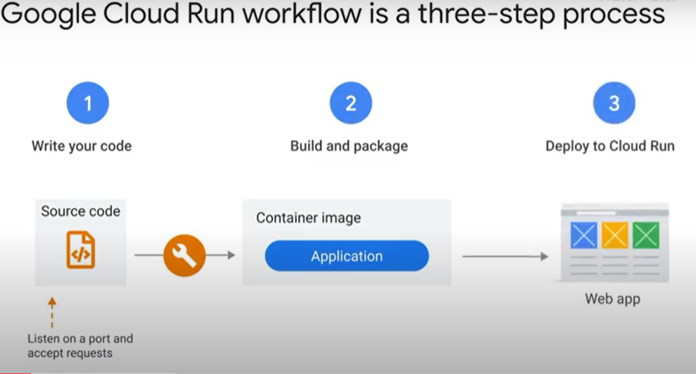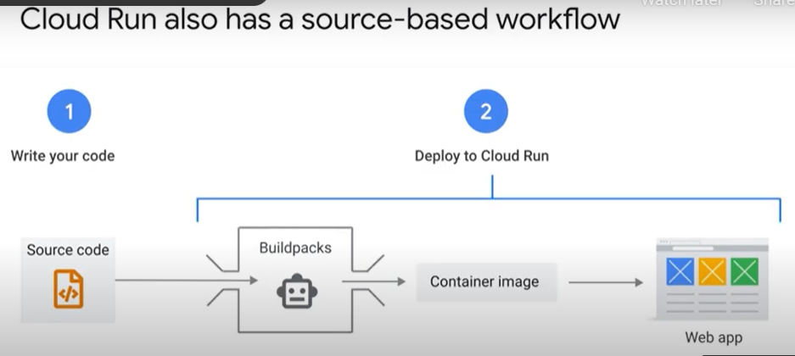
  + 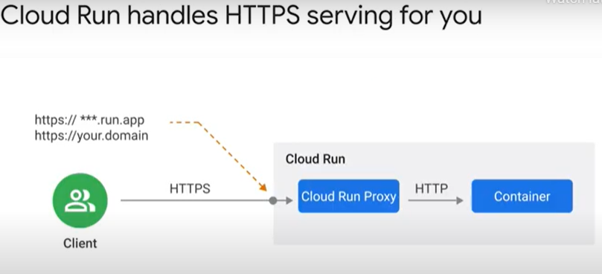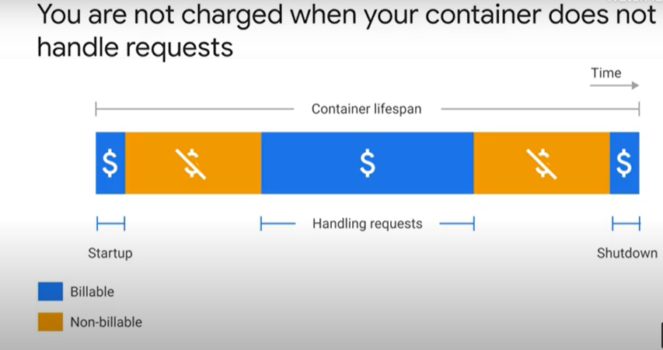
  + 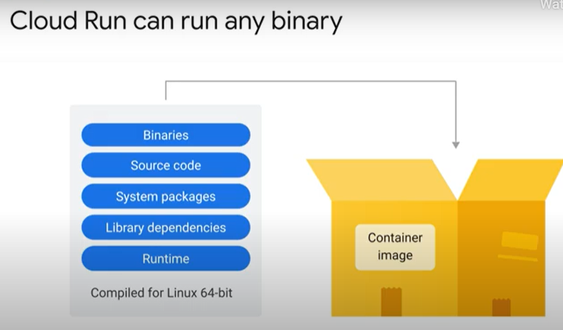
* Typical use cases 6 minutes - <https://youtu.be/fwaOr4VW4IM>
  + 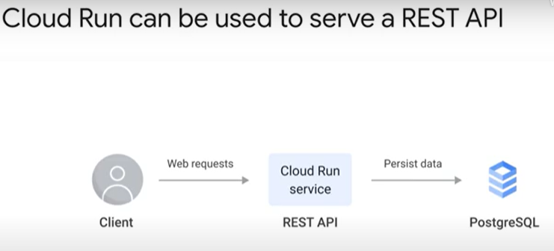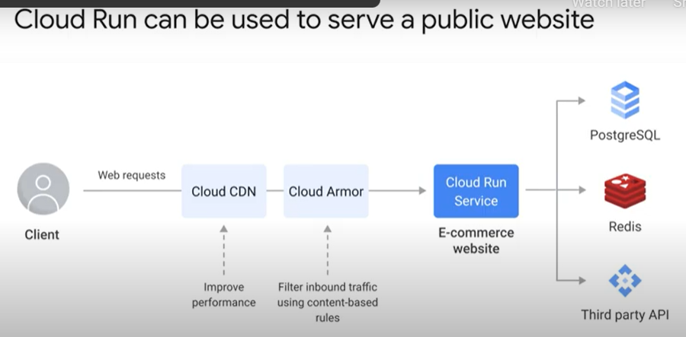
  + 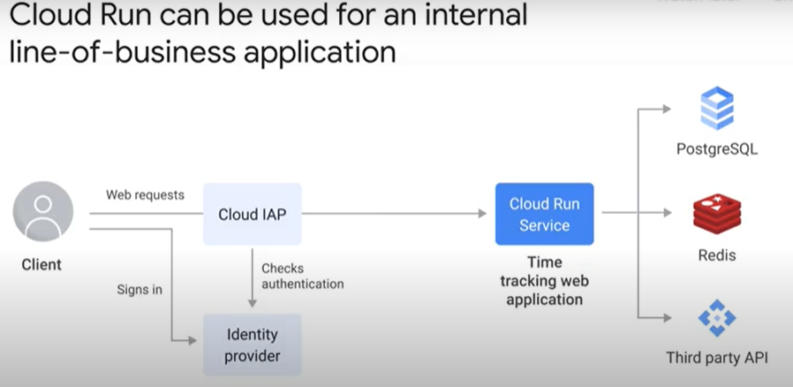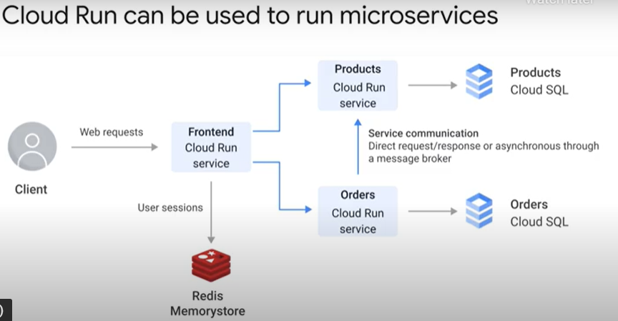
  + 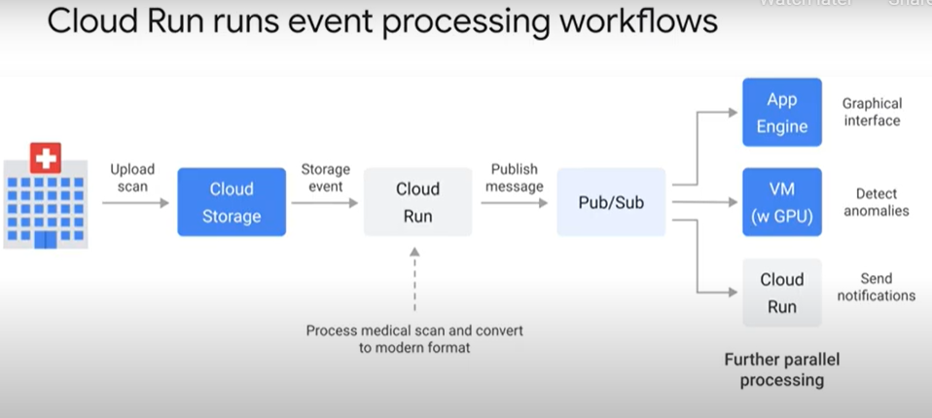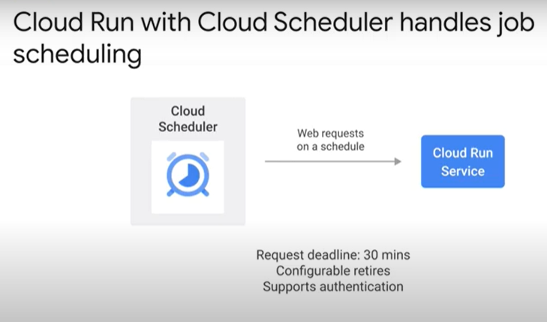
  + 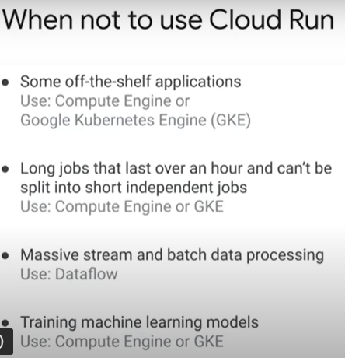
* High availability 4 minutes - <https://youtu.be/P5CmiXKmd4g>
  + 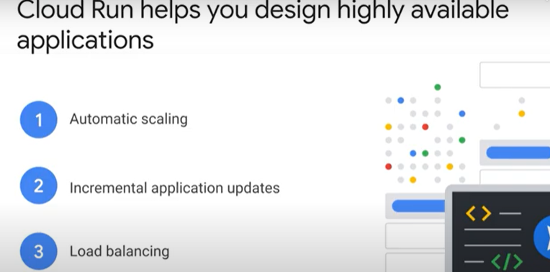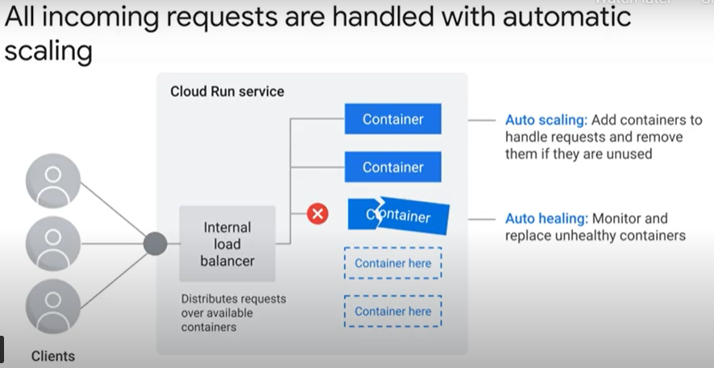
  + 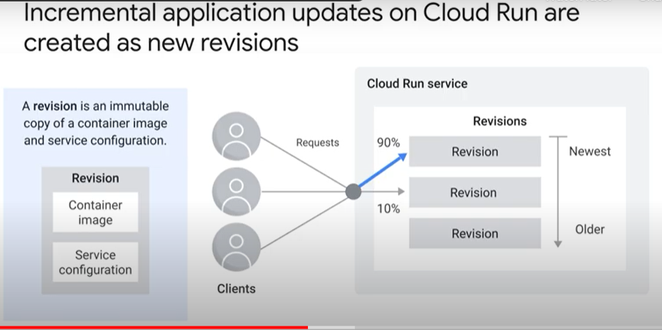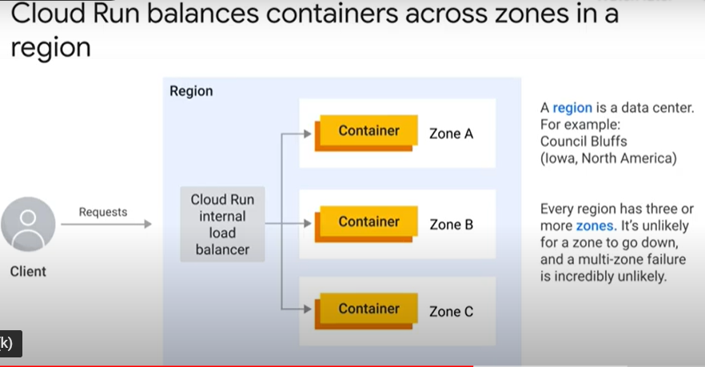
  + 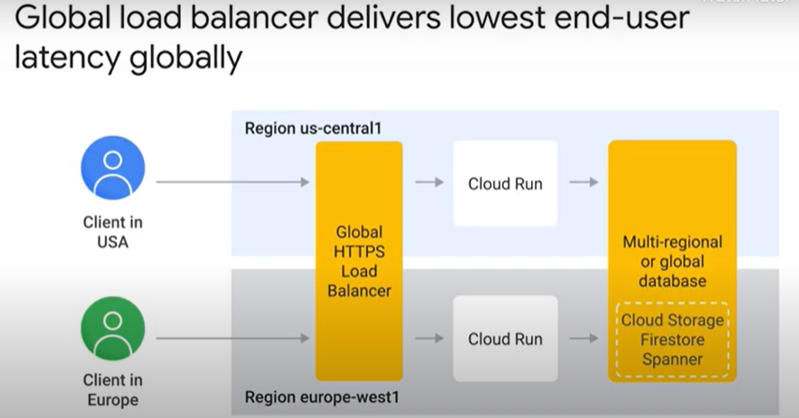
* Concerns about serverless 2 minutes - <https://youtu.be/mq4CBrNcnrk>
  + 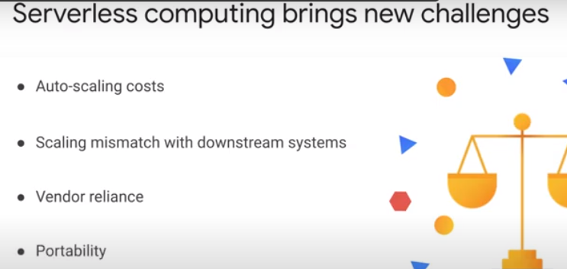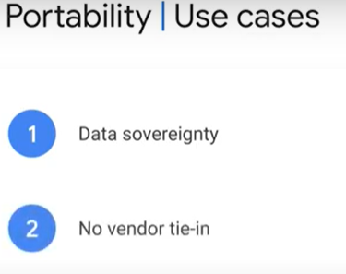
  + 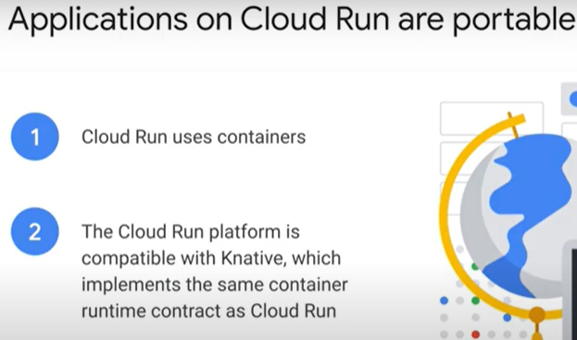
* Positioning on Google Cloud 1 minute - <https://youtu.be/6sUaQIBolXE>
  + 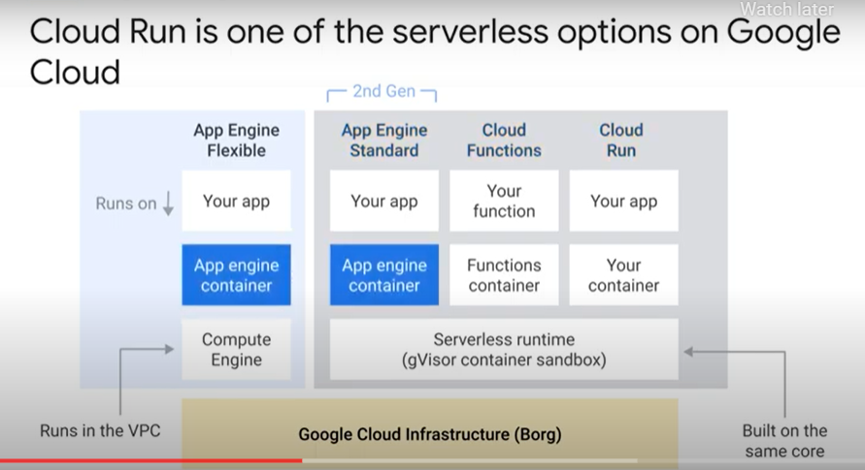

## 6.2. Understanding Cloud Run

* Introduction to containers 3 minutes - <https://youtu.be/eqigDjhJ9II>
  + 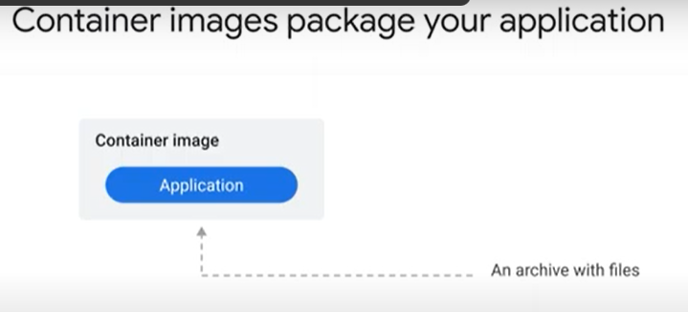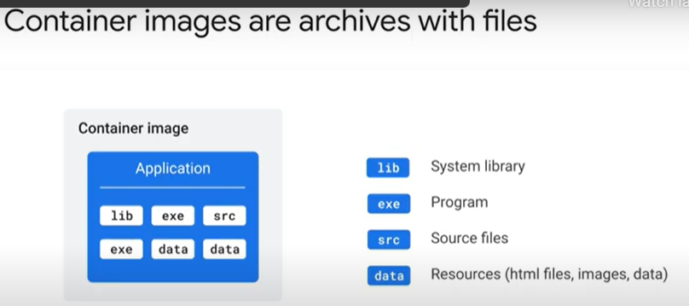
  + 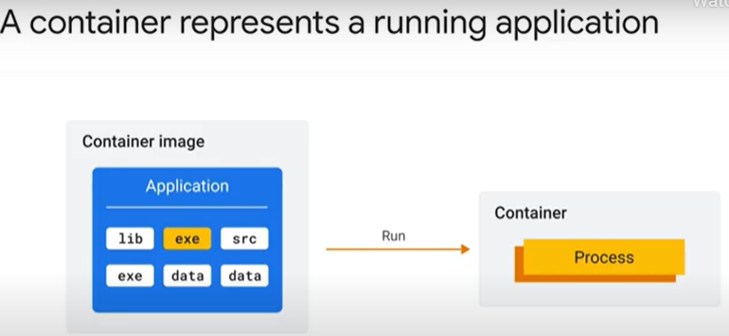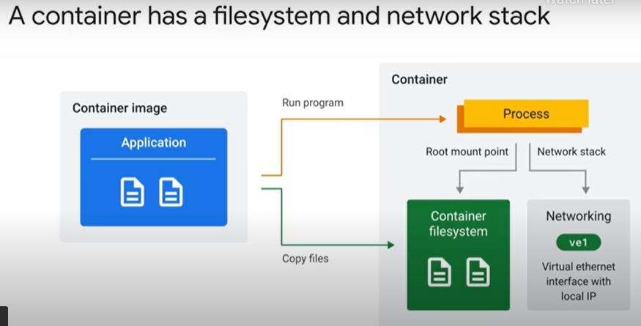
  + 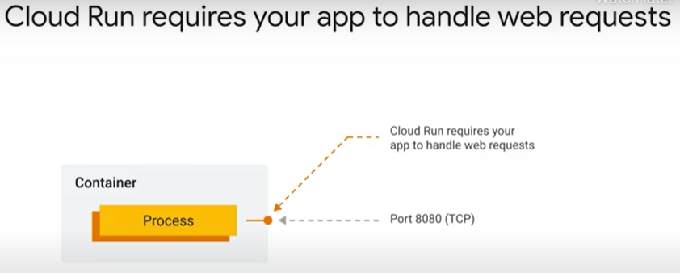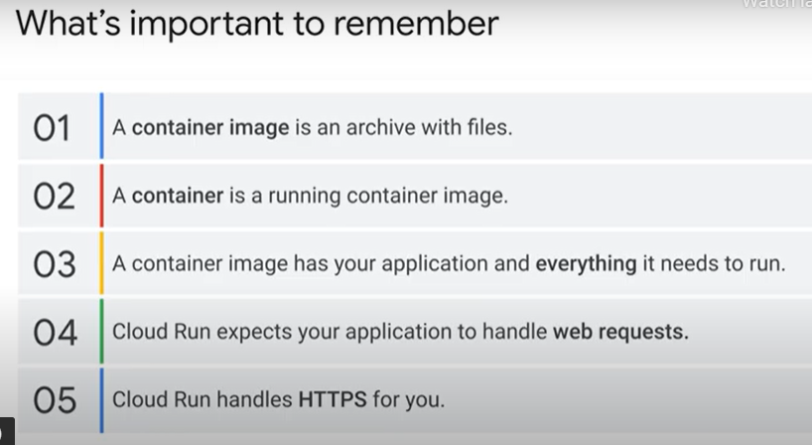
* Running your application on Cloud Run 5 minutes - <https://youtu.be/ZfT7J8D0I28>
  + 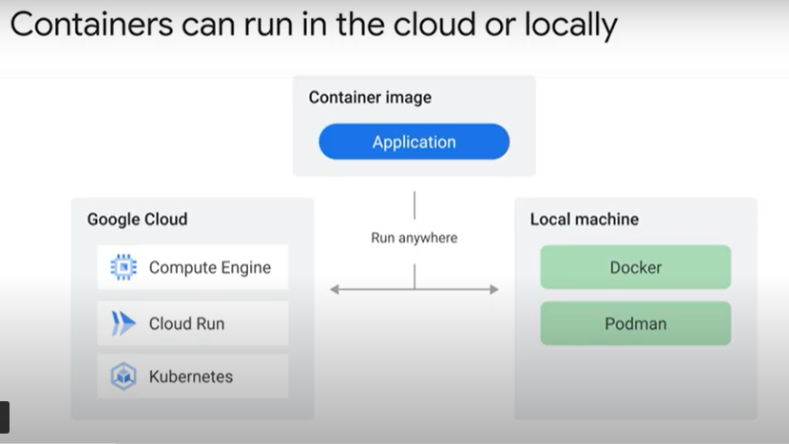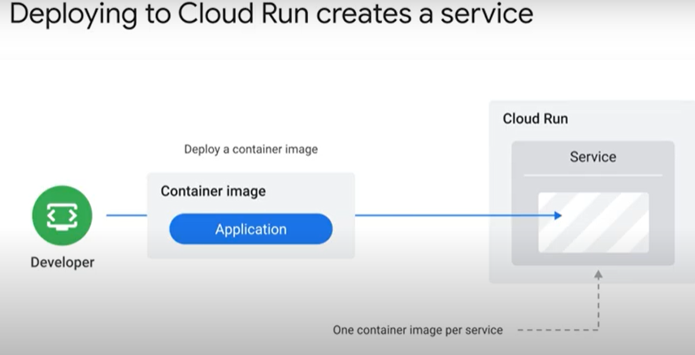
  + 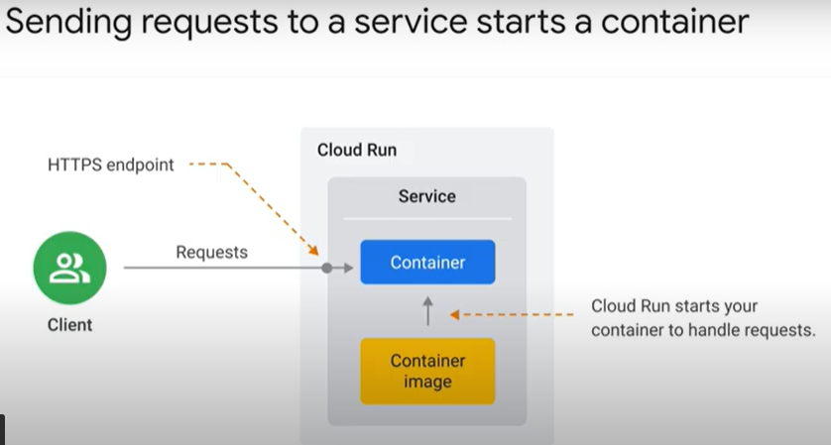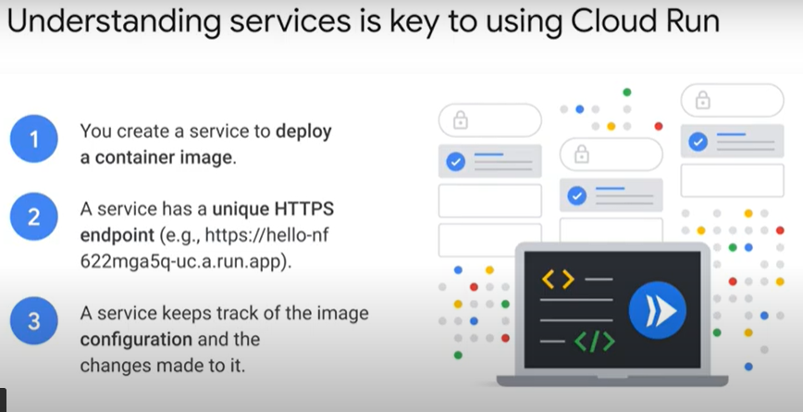
  + 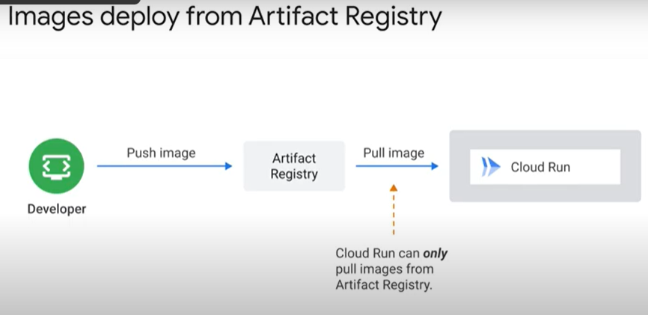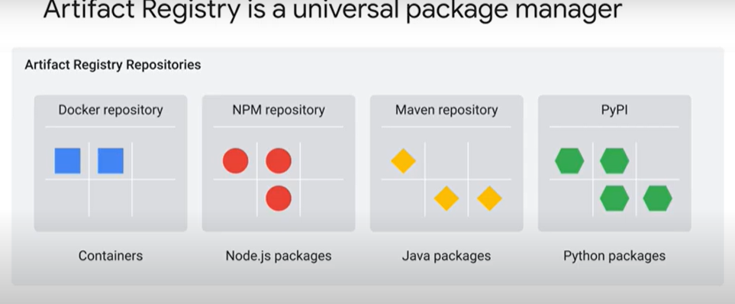
  + 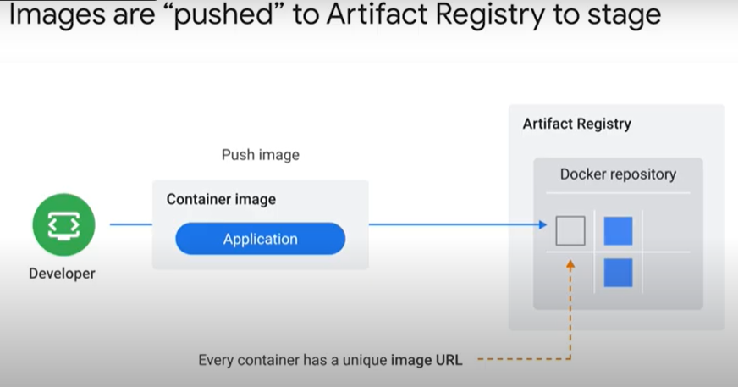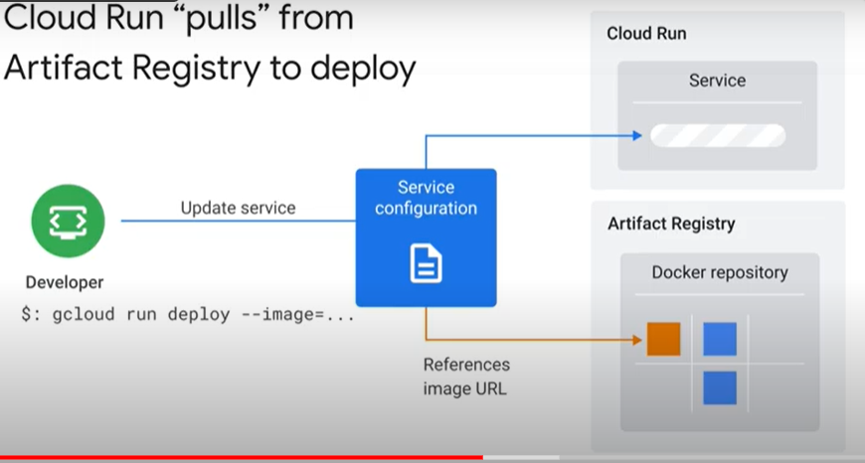
  + 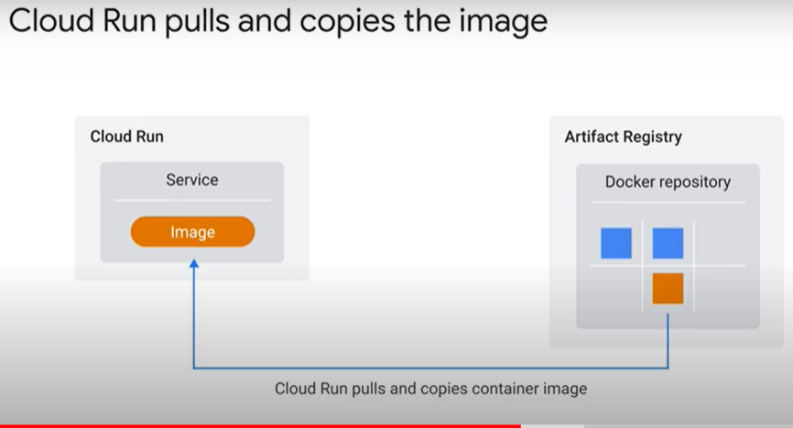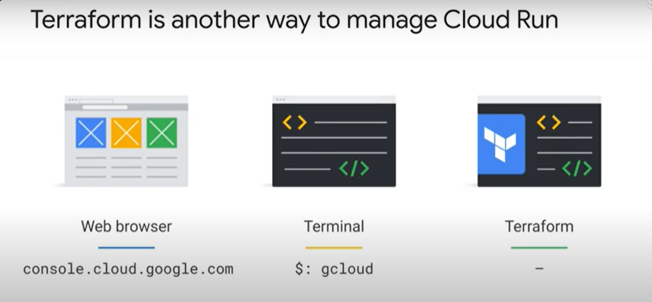

### Hello Cloud Run [APPRUN] - https://www.cloudskillsboost.google/course_sessions/888752/labs/187125

* + Objectives
    - Enable the Cloud Run API.
    - Create a simple Node.js application that can be deployed as a serverless, stateless container.
    - Containerize your application and upload to Container Registry (now called "Artifact Registry.")
    - Deploy a containerized application on Cloud Run.
    - Delete unneeded images to avoid incurring extra storage charges.
  + Overview
    - Cloud Run is a managed compute platform that enables you to run stateless containers that are invocable via HTTP requests. Cloud Run is serverless: it abstracts away all infrastructure management, so you can focus on what matters most — building great applications.
    - Cloud Run is built from Knative, letting you choose to run your containers either fully managed with Cloud Run, or in your Google Kubernetes Engine cluster with Cloud Run on GKE.
    - The goal of this lab is for you to build a simple containerized application image and deploy it to Cloud Run.
  + Reference
    - Basic Linux Commands
    - Below you will find a reference list of a few very basic Linux commands which may be included in the instructions or code blocks for this lab.

|  |  |  |  |  |
| --- | --- | --- | --- | --- |
| **Command -->** | **Action** | **.** | **Command -->** | **Action** |
| **mkdir** (*make directory*) | create a new folder | . | **cd** (*change directory*) | change location to another folder |
| **ls** (*list* ) | list files and folders in the directory | . | **cat** (*concatenate*) | read contents of a file without using an editor |
| **apt-get update** | update package manager library | . | **ping** | signal to test reachability of a host |
| **mv** (*move* ) | moves a file | . | **cp** (*copy*) | makes a file copy |
| **pwd** (*present working directory* ) | returns your current location | . | **sudo** (*super user do*) | gives higher administration privileges |

* + Task 1. Enable the Cloud Run API and configure your Shell environment:
    - From Cloud Shell, enable the Cloud Run API :
      * gcloud services enable run.googleapis.com
    - Set the compute region
      * gcloud config set compute/region us-central1
    - Create a LOCATION environment variable
      * LOCATION="us-central1"
  + Task 2. Write the sample application
    - In this task, you will build a simple express-based NodeJS application which responds to HTTP requests.
    - In Cloud Shell create a new directory named helloworld, then move your view into that directory:
      * mkdir helloworld && cd helloworld
    - Create a package.json file, then add the following content to it:
      * {
      * "name": "helloworld",
      * "description": "Simple hello world sample in Node",
      * "version": "1.0.0",
      * "main": "index.js",
      * "scripts": {
      * "start": "node index.js"
      * },
      * "author": "Google LLC",
      * "license": "Apache-2.0",
      * "dependencies": {
      * "express": "^4.17.1"
      * }
      * }
    - Most importantly, the file above contains a start script command and a dependency on the Express web application framework.
    - Next, in the same directory, create a index.js file, and copy the following lines into it:
      * const express = require('express');
      * const app = express();
      * const port = process.env.PORT || 8080;
      * app.get('/', (req, res) => {
      * const name = process.env.NAME || 'World';
      * res.send(`Hello ${name}!`);
      * });
      * app.listen(port, () => {
      * console.log(`helloworld: listening on port ${port}`);
      * });
    - This code creates a basic web server that listens on the port defined by the PORT environment variable. Your app is now finished and ready to be containerized and uploaded to Container Registry.
    - You can use many other languages to get started with Cloud Run. You will find instructions for Go, Python, Java, PHP, Ruby, Shell scripts, and others here: https://cloud.google.com/run/docs/quickstarts/build-and-deploy
  + Task 3. Containerize your app and upload it to Artifact Registry
    - To containerize the sample app, create a new file named Dockerfile in the same directory as the source files, and add the following content :
      * # Use the official lightweight Node.js 12 image.
      * # https://hub.docker.com/_/node
      * FROM node:12-slim
      * # Create and change to the app directory.
      * WORKDIR /usr/src/app
      * # Copy application dependency manifests to the container image.
      * # A wildcard is used to ensure copying both package.json AND package-lock.json (when available).
      * # Copying this first prevents re-running npm install on every code change.
      * COPY package*.json ./
      * # Install production dependencies.
      * # If you add a package-lock.json, speed your build by switching to 'npm ci'.
      * # RUN npm ci --only=production
      * RUN npm install --only=production
      * # Copy local code to the container image.
      * COPY . ./
      * # Run the web service on container startup.
      * CMD [ "npm", "start" ]
    - Now, build your container image using Cloud Build by running the following command from the directory containing the Dockerfile. (Note the $GOOGLE_CLOUD_PROJECT environmental variable in the command, which contains your lab's Project ID):
      * gcloud builds submit --tag gcr.io/$GOOGLE_CLOUD_PROJECT/helloworld
    - Cloud Build is a service that executes your builds on GCP. It executes a series of build steps, where each build step is run in a Docker container to produce your application container (or other artifacts) and push it to Cloud Registry, all in one command.
    - Once pushed to the registry, you will see a SUCCESS message containing the image name (gcr.io/[PROJECT-ID]/helloworld). The image is stored in Artifact Registry and can be re-used if desired.
    - List all the container images associated with your current project using this command :
      * gcloud container images list
    - To run and test the application locally from Cloud Shell, start it using this standard docker command :
      * docker run -d -p 8080:8080 gcr.io/$GOOGLE_CLOUD_PROJECT/helloworld
    - In the Cloud Shell window, click on Web preview and select Preview on port 8080.
      * If the docker command cannot pull the remote container image then try running this :
        + gcloud auth configure-docker
  + Task 4. Deploy to Cloud Run
    - Deploying your containerized application to Cloud Run is done using the following command adding your Project-ID:
      * gcloud run deploy --image gcr.io/$GOOGLE_CLOUD_PROJECT/helloworld --allow-unauthenticated --region=$LOCATION
    - The allow-unauthenticated flag in the command above makes your service publicly accessible.
    - When prompted:
      * confirm the service name by pressing Enter
    - On success, the command line displays the service URL & visit in browser
    - Congratulations! You have just deployed an application packaged in a container image to Cloud Run. Cloud Run automatically and horizontally scales your container image to handle the received requests, then scales down when demand decreases. In your own environment, you only pay for the CPU, memory, and networking consumed during request handling.
    - For this lab you used the gcloud command-line. Cloud Run is also available via Cloud Console.
    - From the Navigation menu, in the Compute section, click Cloud Run and you should see your helloworld service listed:
      * 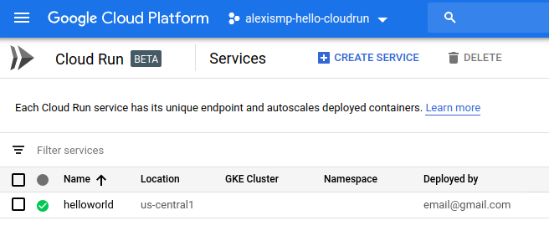
  + Task 5. Clean up
    - While Cloud Run does not charge when the service is not in use, you might still be charged for storing the built container image.
    - You can either decide to delete your GCP project to avoid incurring charges, which will stop billing for all the resources used within that project, or simply delete your helloworld image using this command :
      * gcloud container images delete gcr.io/$GOOGLE_CLOUD_PROJECT/helloworld
    - To delete the Cloud Run service, use this command :
      * gcloud beta run services delete helloworld

### Autoscaling and on-demand containers 5 minutes - https://youtu.be/qAYurXK8N3c

* + 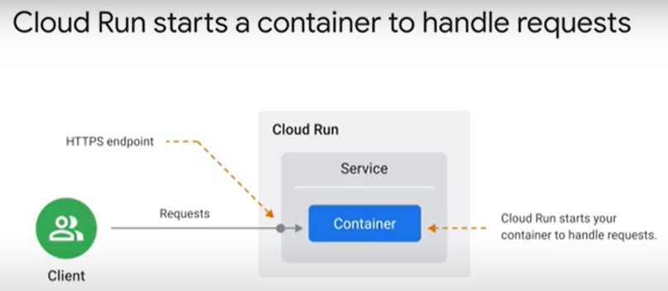 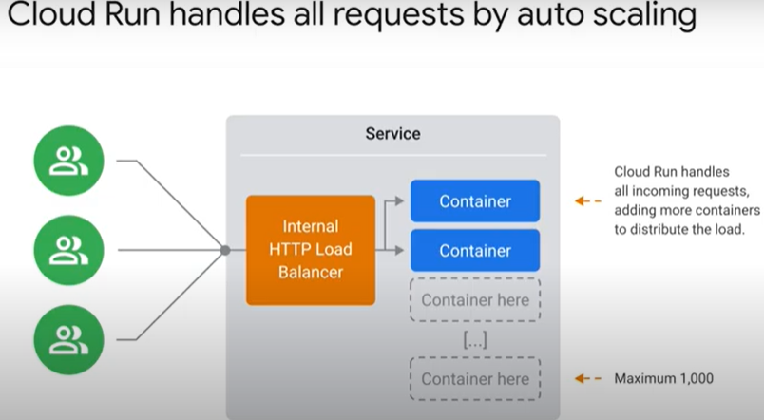
  + 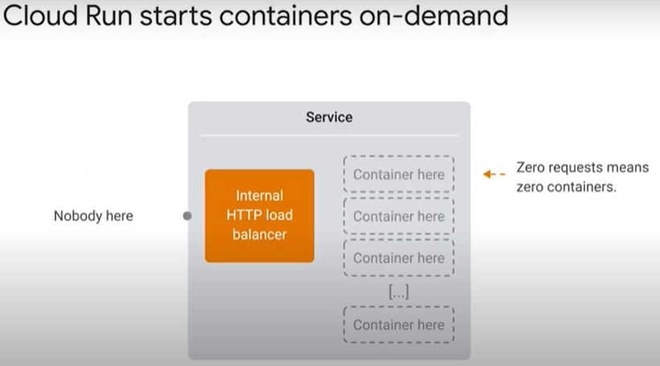 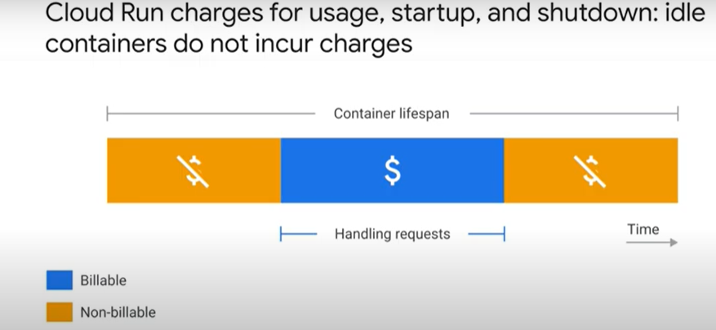
  + 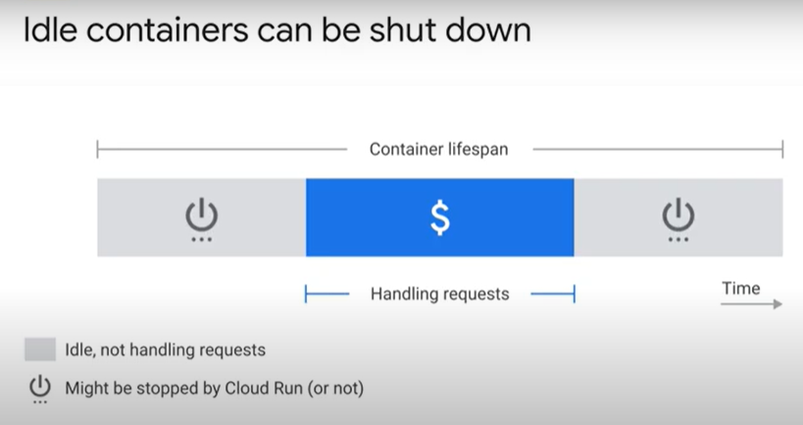 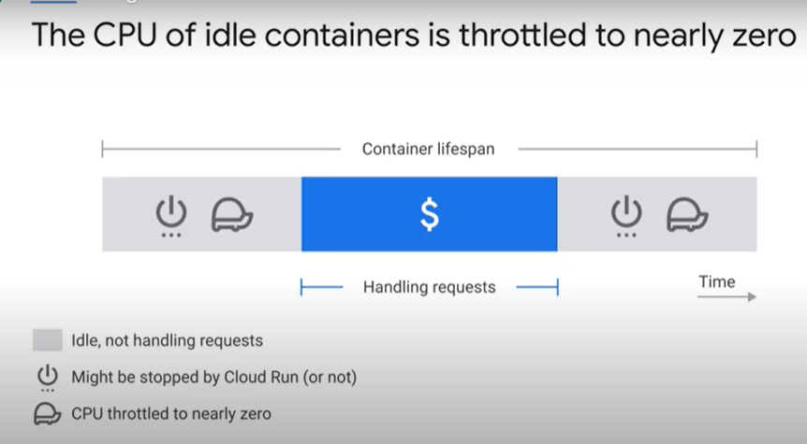
  + 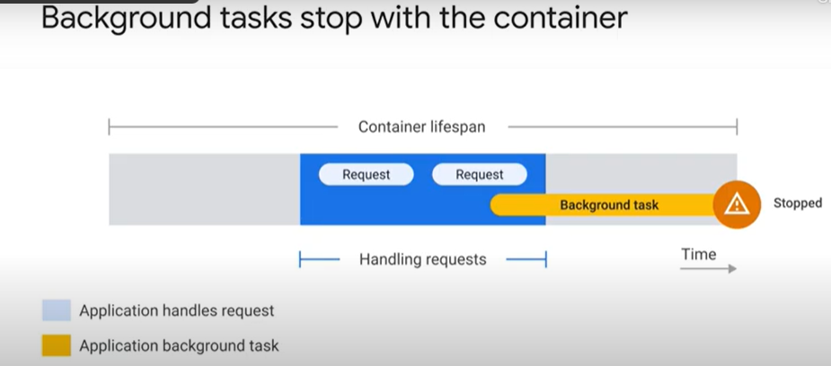 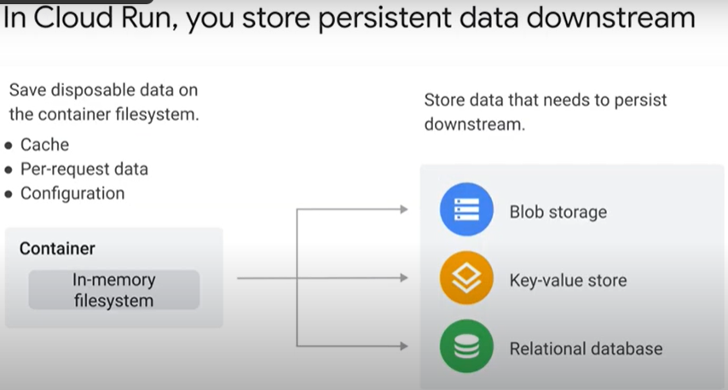
  + 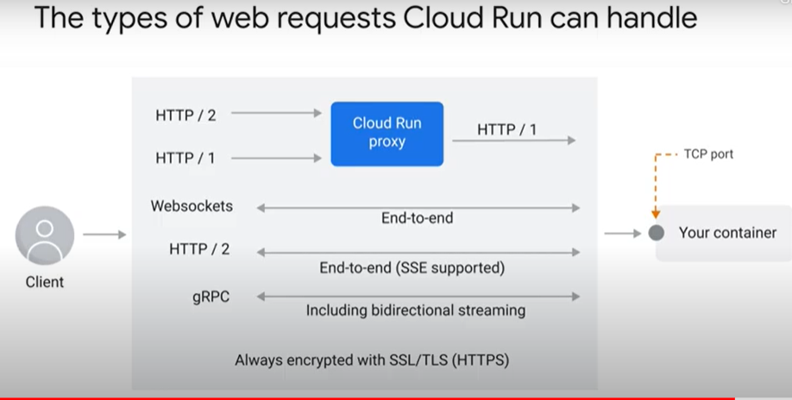
* Quiz
  + Pricing on Cloud Run is determined by: (select all that apply)
    - A small fee per one million requests served
      * Correct! You will, however, get your first 2 million requests free per month. If you go over that, you will pay according to your “tier,” which is location-dependent.
    - Network egress from the container
      * Correct! Data egress over the network incurs charges.
    - The system resources a container uses while handling a request or during startup/shutdown
      * Correct! The price of container time depends upon CPU and memory. A container with more vCPU and memory is more expensive to run.
  + Cloud Run can only pull images from:
    - Artifact Registry
      * Correct! If you use other container registries, you will need to push them to Container Registry first before you use them.
  + You should complete all work before you return a response to a web request for the following reason:
    - Because Cloud Run shuts down and throttles idle containers so any tasks you run in the background after returning a response might not finish.
      * Correct! If you return your HTTP response before all tasks are completed, you run the risk of losing your data when the container is throttled.

## 6.3. Building Container Images

* Deep dive into a container image 6 minutes - <https://youtu.be/5VAbTQlKmI0>
  + 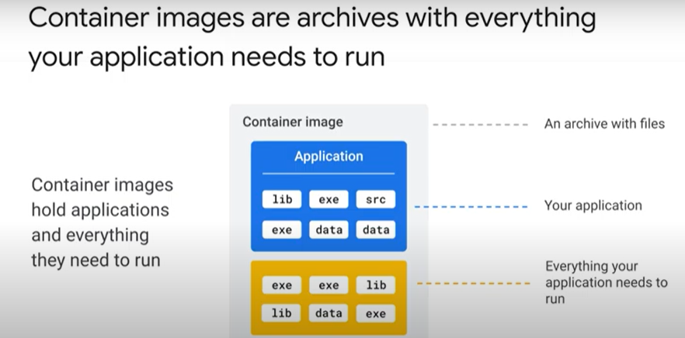 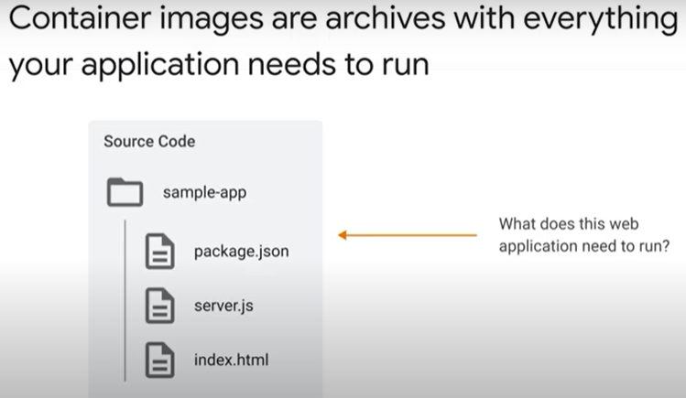
  + 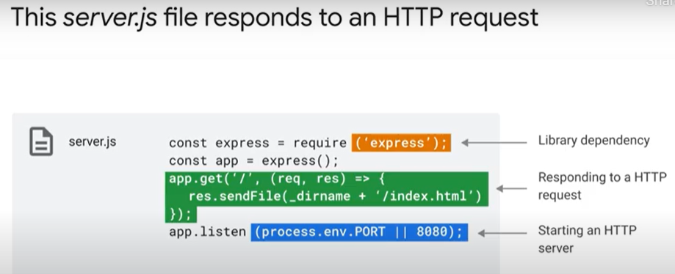 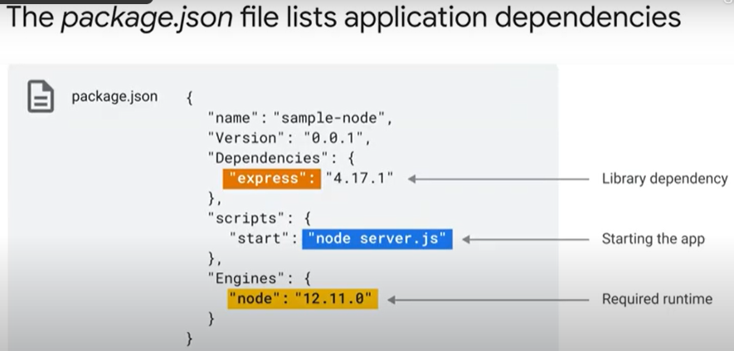
  + 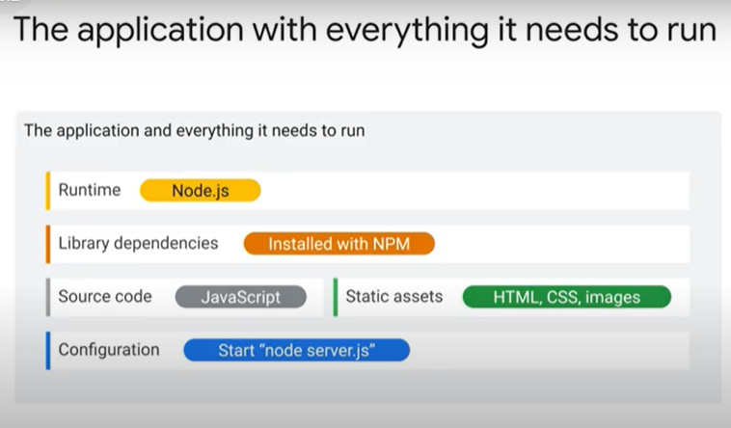 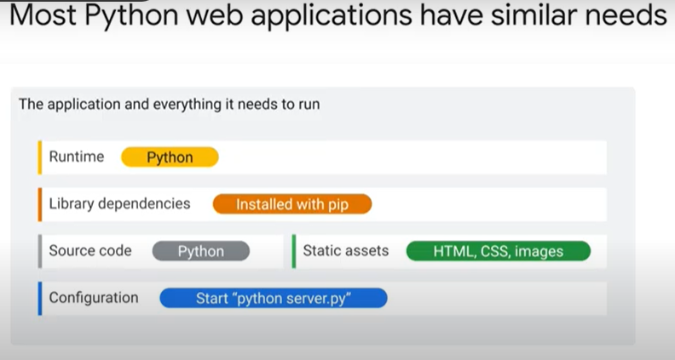
  + 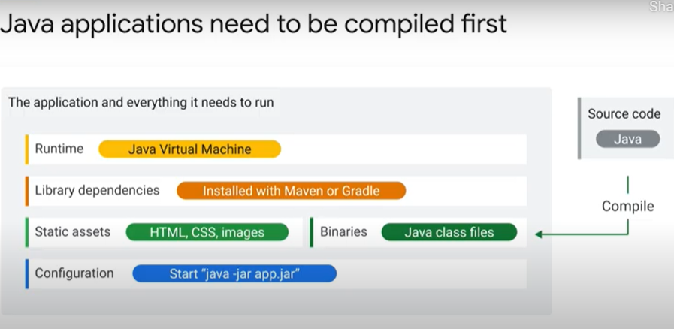 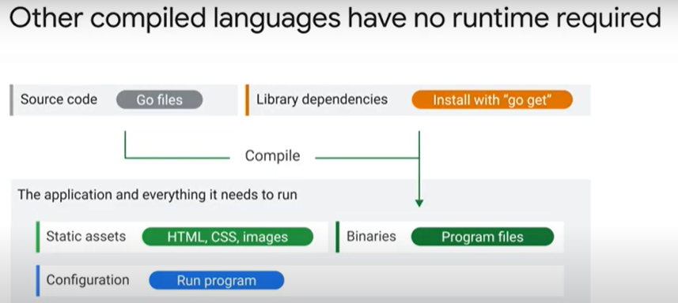
  + 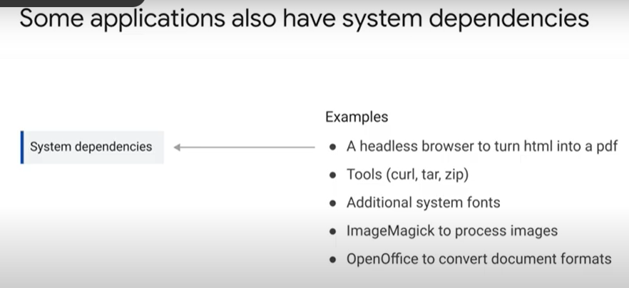 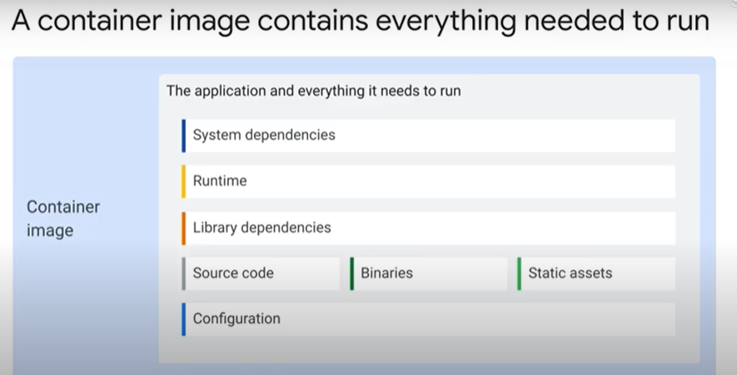
  + 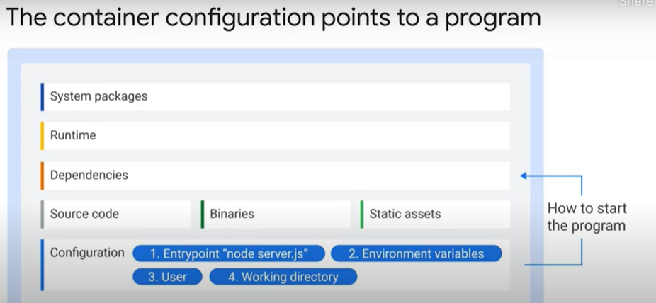
* Building images with Docker 8 minutes - <https://youtu.be/QNga4OMYEvM>
  + 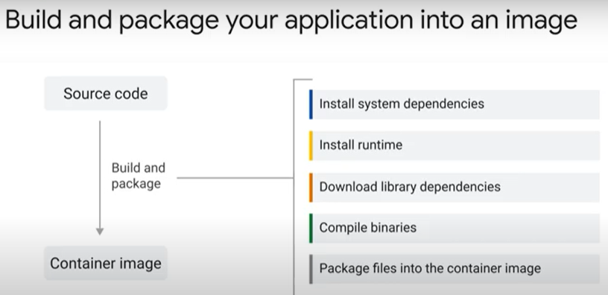 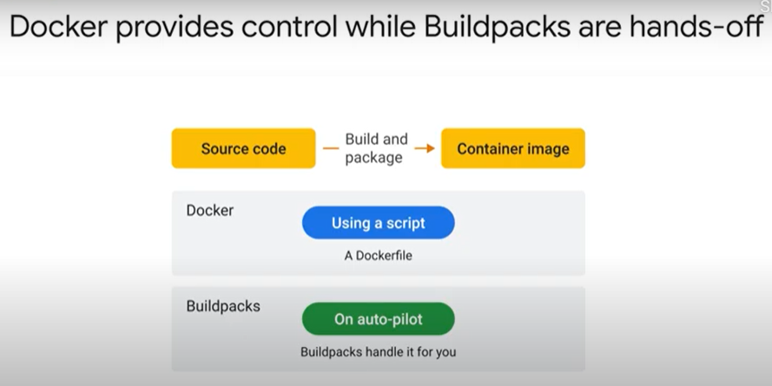
  + 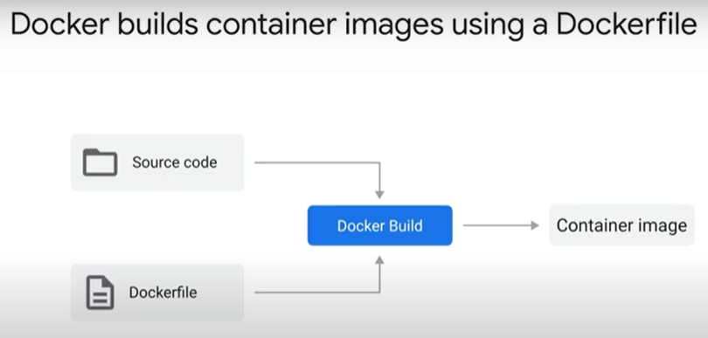 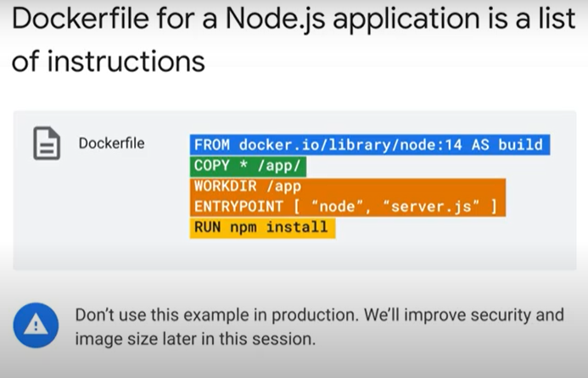
  + 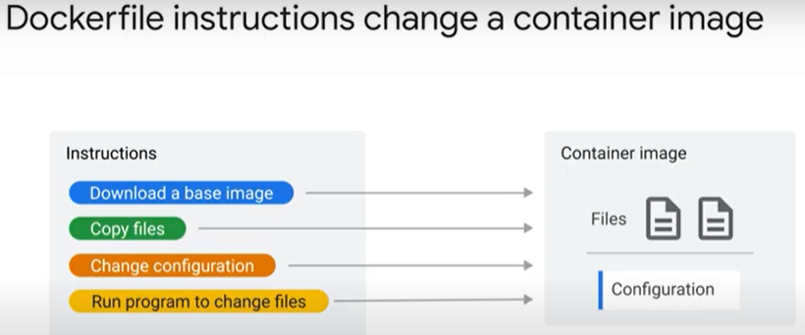 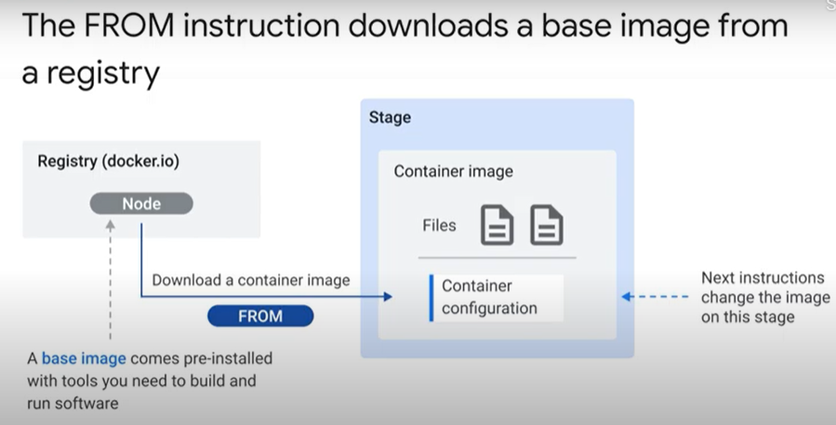 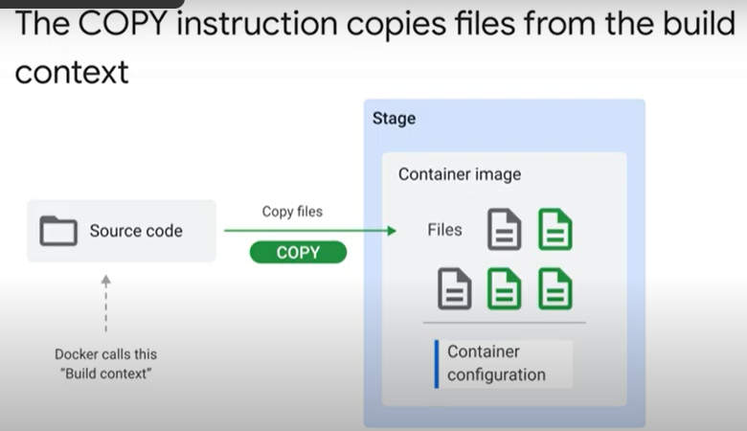 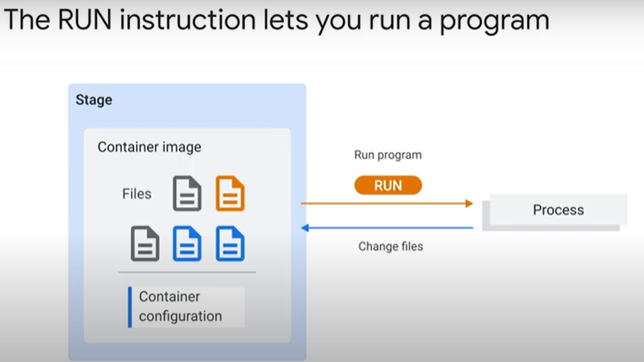
  + 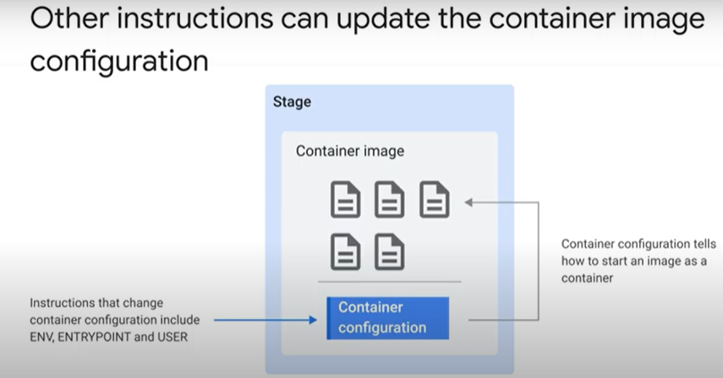 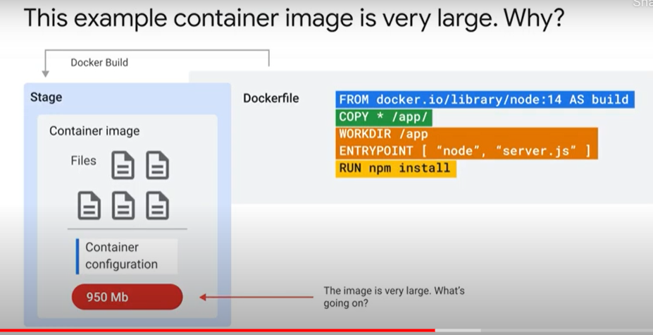
  + 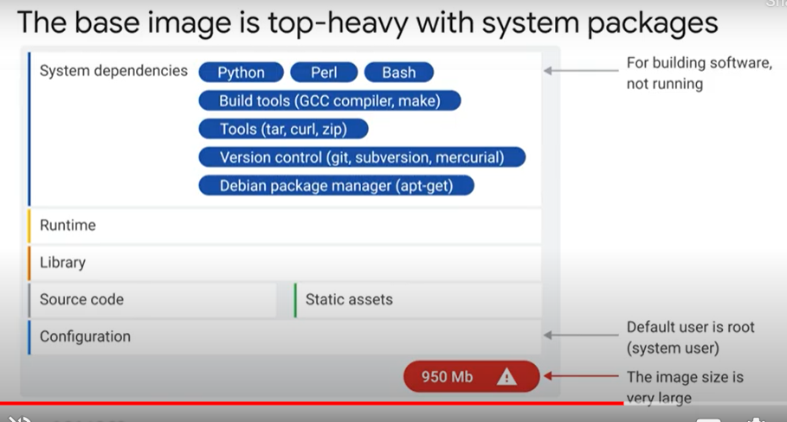 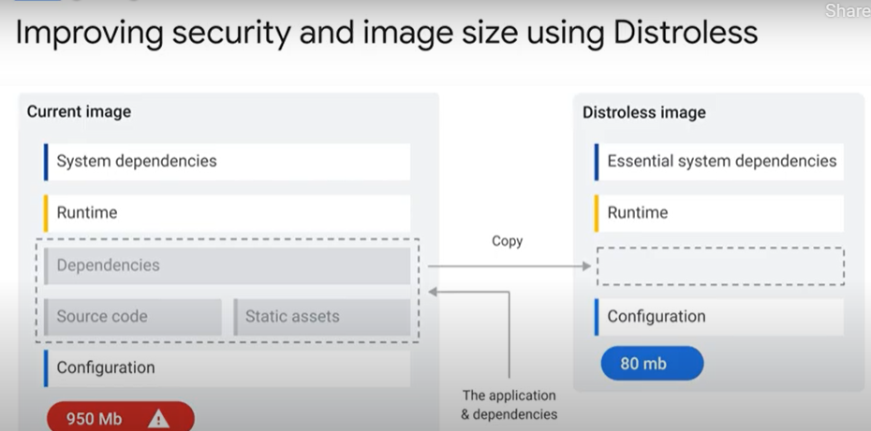
  + 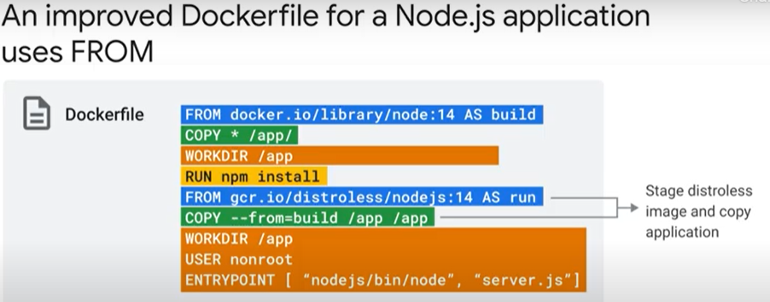 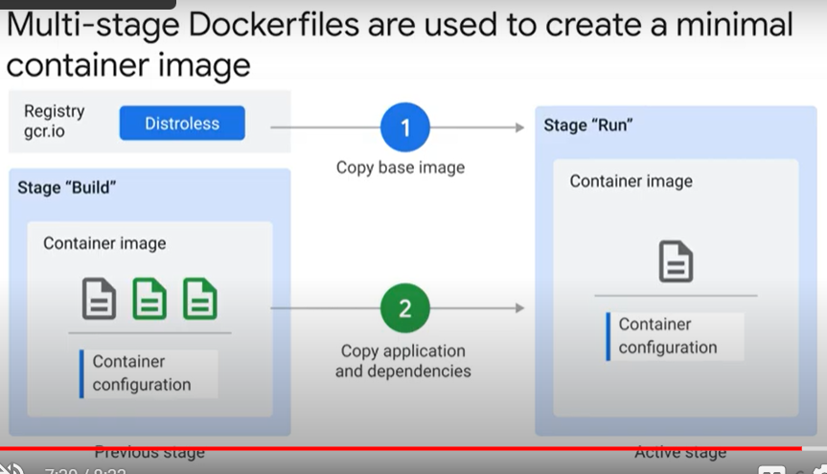
  + 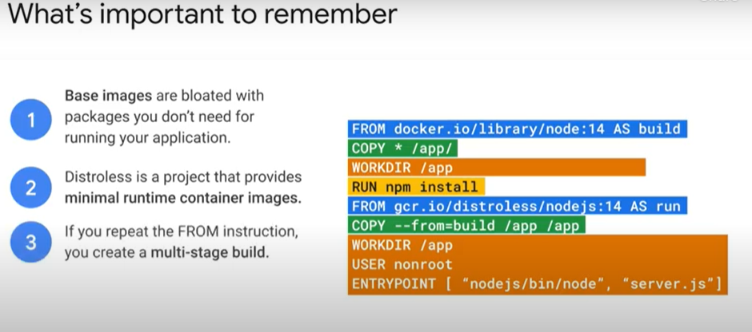 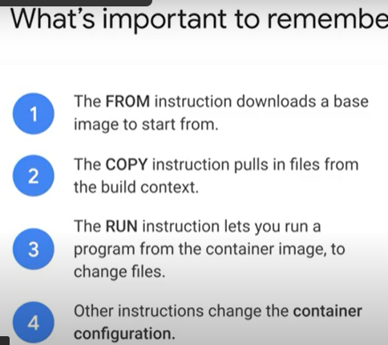
* Building images with Buildpacks 4 minutes - <https://youtu.be/PmkJs3dmI9Q>
  + 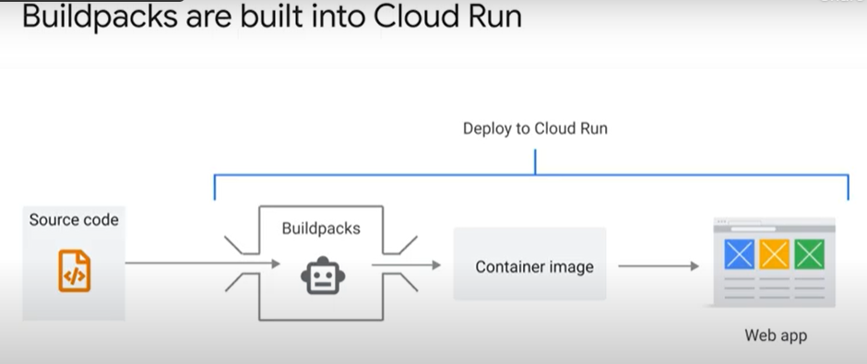 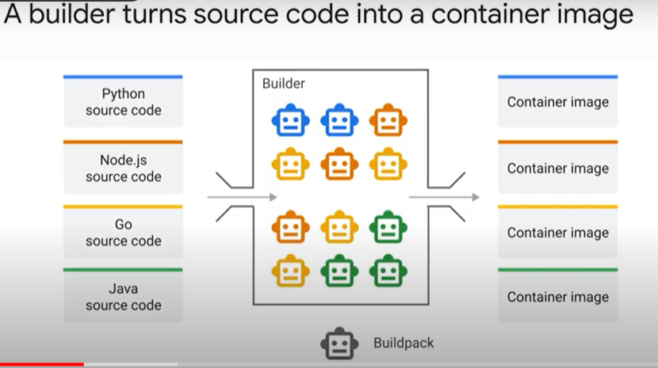
  + 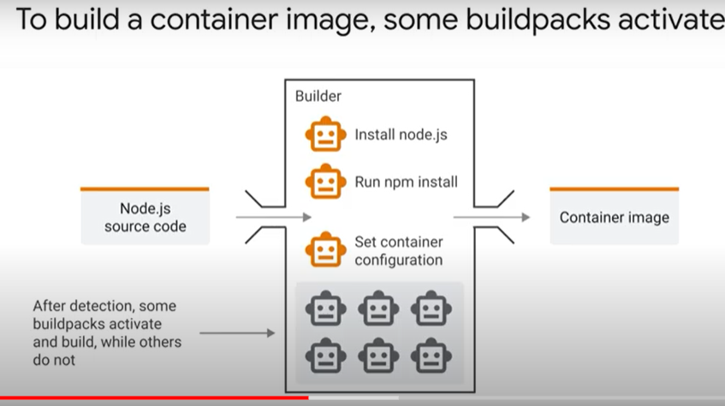 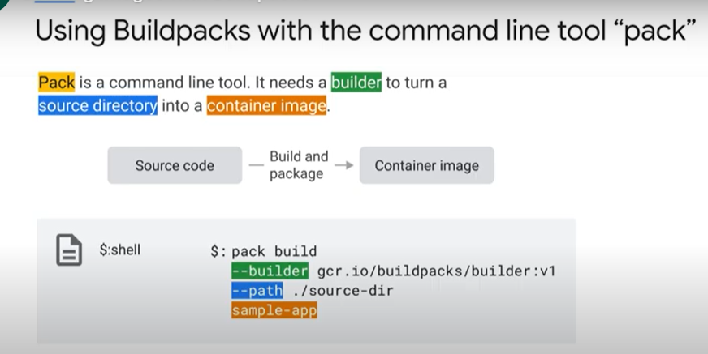
  + 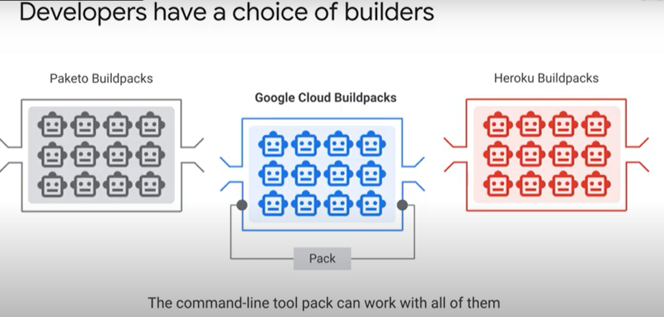 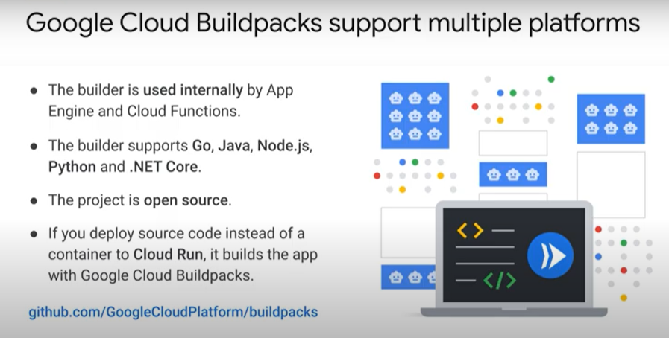

### Creating Application Containers with Google Cloud Buildpacks [APPRUN] 45 minutes

* + Objectives
    - Build a sample application with pack and the Google Cloud Buildpacks builder.
    - Deploy the resulting container image to Cloud Run.
    - Deploy the same image again, this time using Cloud Run (which uses Google Cloud Buildpacks) to perform the -build and package the container image for you.
  + Overview
    - In this lab, you learn about Google Cloud buildpacks, which allow developers to create containerized applications and deploy them without the need to install Docker locally, or create a Dockerfile. You will then take the same image and learn to deploy it directly on Cloud Run, allowing Cloud Run to do the building for you.
  + Task 1. Enable the Cloud Run API and configure your Shell environment
    - gcloud services enable run.googleapis.com
    - gcloud config set compute/region us-central1
  + Task 2. List the pack CLI commands
    - The pack CLI has already been installed on your lab account. To see the list of pack commands available to you, open your cloud shell terminal and type pack. You should see output similar to the example below:
    - Which of the commands you see in your output do you think will be needed to generate a container image from your source code?
      * build
  + Task 3. Clone the Buildpack sample repository
    - Google Cloud Buildpack helps developers focus on writing code, not on containerizing it. Buildpack supports the following languages: Java, Node, Go, Python, and .NET (C#). Google provides a Buildpack Repository containing sample code you can use to practice using Buildpack to easily containerize and deploy applications.
    - To use the provided sample applications in the language of your choice, you will first need to clone the Buildpack repository and then select a sample to build with the pack build command.
      * git clone https://github.com/GoogleCloudPlatform/buildpack-samples.git
    - Select your sample application
      * Copy code from the language of your choice, shown in the list in the table below. Use this code in the cloud shell to build an application container. (You only need to create one container in one of these languages for the purposes of this lab.)
      * JavaScript
        + cd buildpack-samples/sample-node
        + pack build --builder=gcr.io/buildpacks/builder sample-node
      * Python
        + cd buildpack-samples/sample-node-python
        + pack build --builder=gcr.io/buildpacks/builder sample-python
      * Go / Java (Gradle) / Java (Maven) / DotNet
    - Run your new build container in Docker
      * Run the appropriate section from the command below to bind the sample app created in the previous step to port 8080, so that it can be accessed via the browser.
    - JavaScript / Python / Go / Java (Gradle) / Java (Maven) / DotNet
      * docker run -it -e PORT=8080 -p 8080:8080 sample-python
    - In the Cloud Shell window, click on the Web preview icon and select Preview on port 8080.
  + Task 4. Build and run your sample App on Cloud Run
    - In the tasks above, we have built a container image locally using pack. After this, the next step would generally be pushing the container to Artifact Registry and then deploy to Cloud Run. However, it is also possible to have Cloud Run do all of the building and deployment for you.
    - Use the one-step gcloud command to deploy your container:
      * gcloud beta run deploy --source .
    - When prompted:
      * Confirm the service name by pressing Enter.
      * Choose us-central1 region.
      * If asked to allow unauthenticated invocations, type Y and press Enter.

### Quiz

* + Which of the following statements about Buildpacks is true: (select all that apply)
    - Google Cloud Buildpacks support Go, Node.js, Python, Java, and .NET Core
    - Buildpacks offers you a hands-off approach to building a container image
    - Google Cloud Buildpacks are used as the build system for App Engine, Cloud Run and Cloud Functions
  + Question prompt goes here
    - Multi-stage builds are used to create optimized and secure container images.
    - A Dockerfile is a script to build a container image.
    - Dockerfiles are a powerful, transparent, and flexible way to create container images.
  + A container image is:
    - A package with your application and everything it needs to run.
      * Correct! Including everything your application needs to run is how containers are able to be written once, but run anywhere.

## 6.4. Diving Deeper into Cloud Run

### Container lifecycle 1 minute - <https://youtu.be/uYc61KlTgsY>

* + 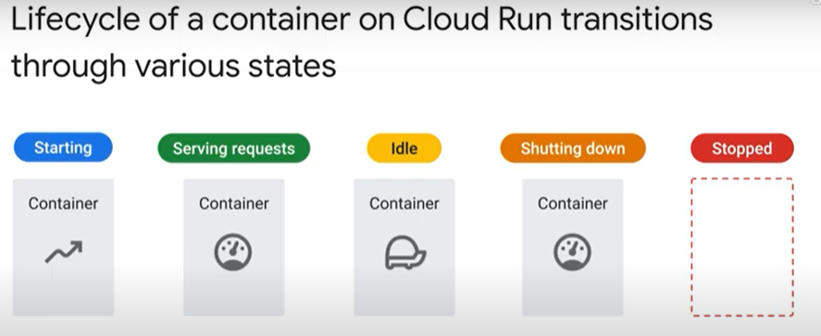
* Starting a container 2 minutes - <https://youtu.be/8ad7sX6YYnk>
  + 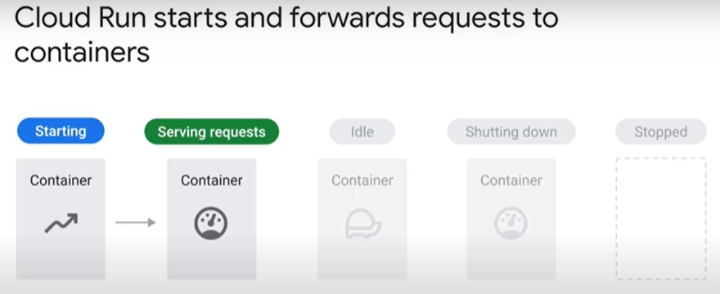 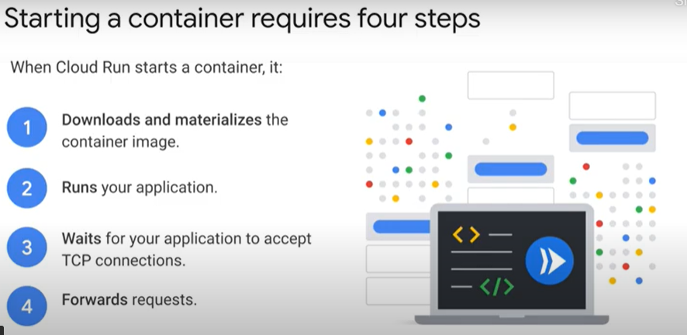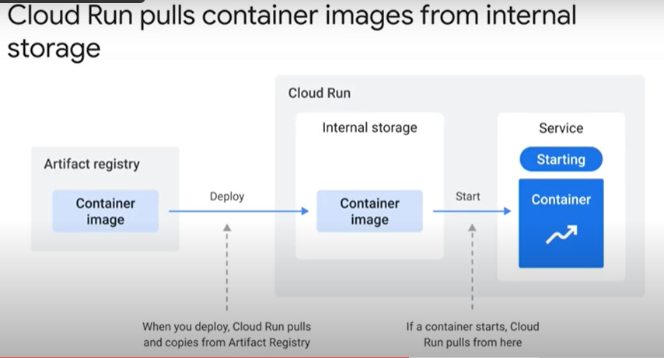
* Serving Requests 2 minutes - <https://youtu.be/a-qXHUXC8ic>
  + 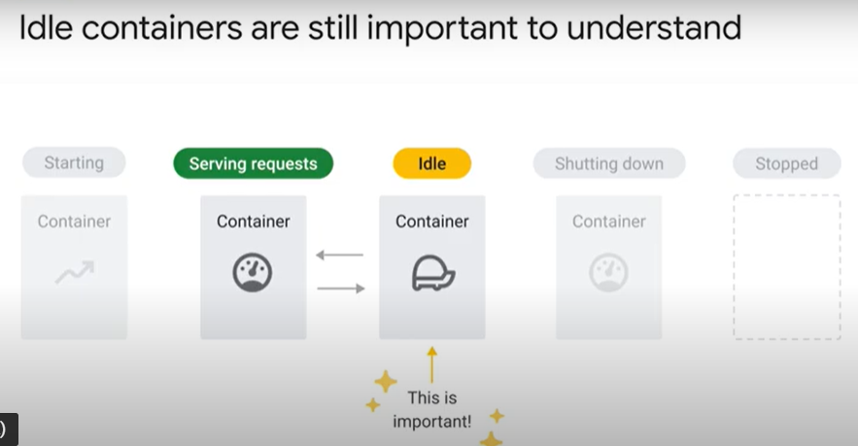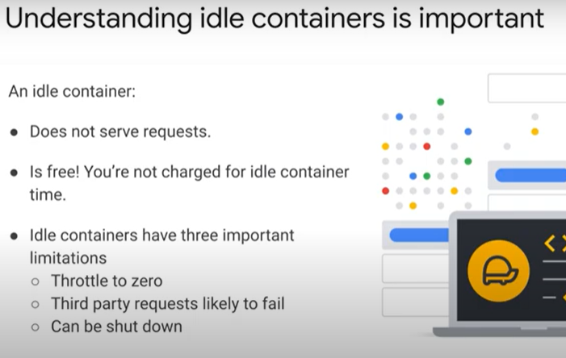
  + 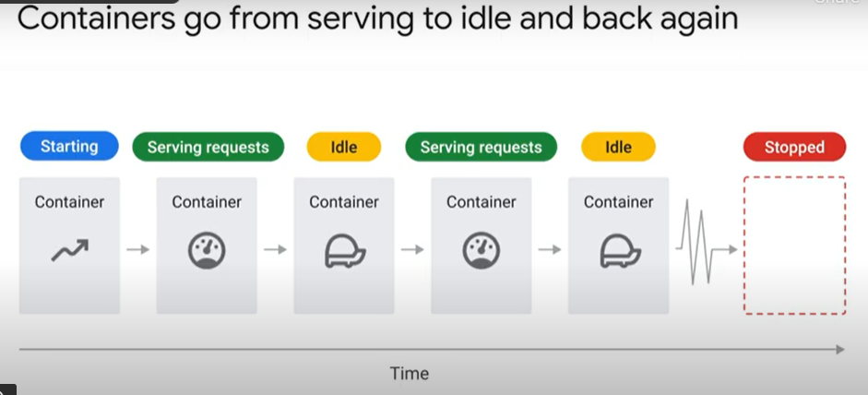
* Handling shutdown 5 minutes
  + 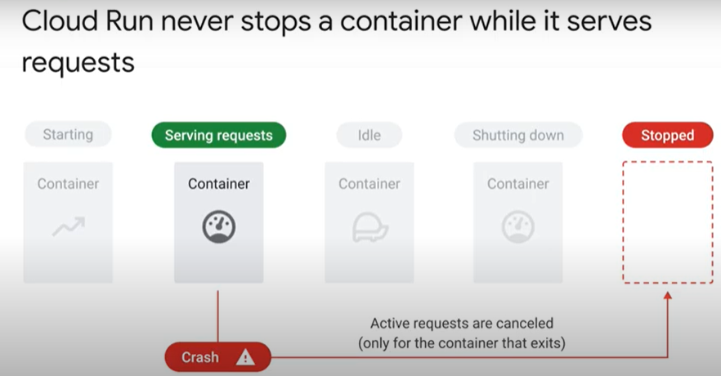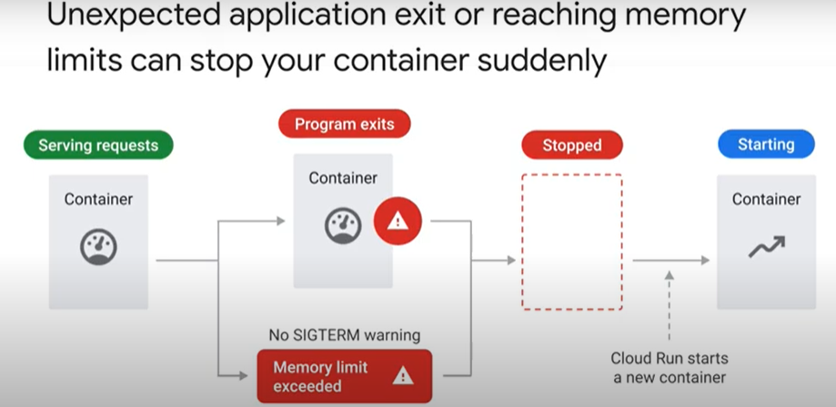
  + 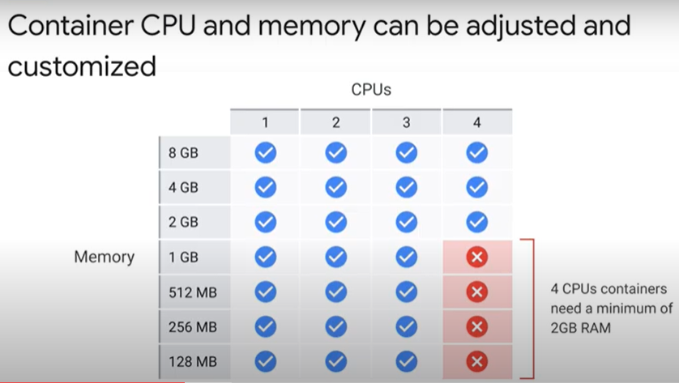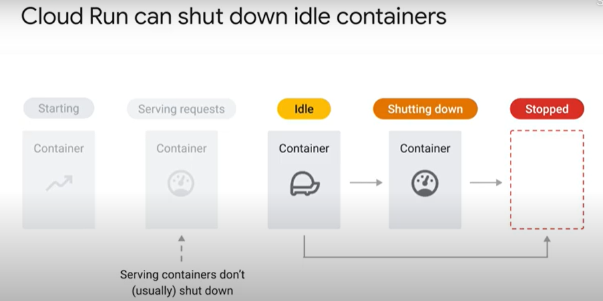
  + 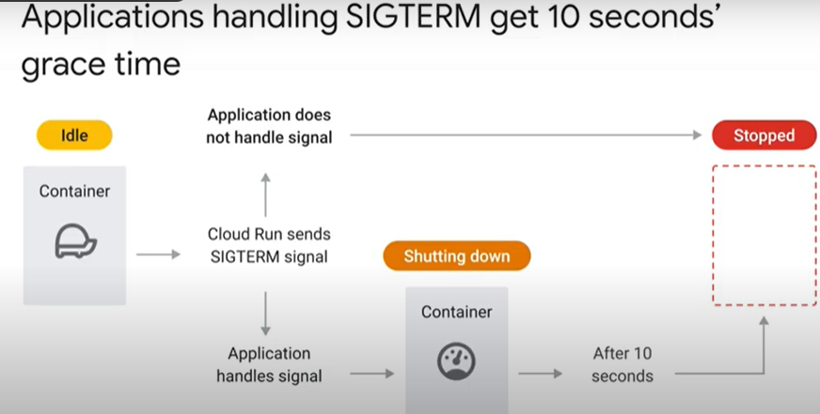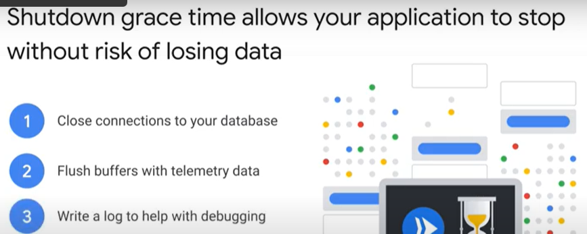
  + 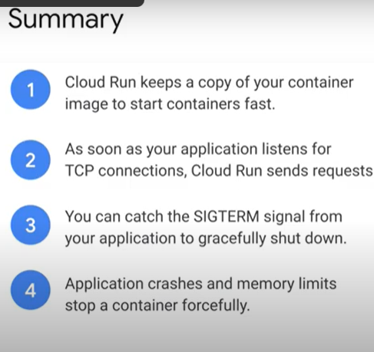
* Request queuing 4 minutes - <https://youtu.be/TWgAyLQAbv8>
  + 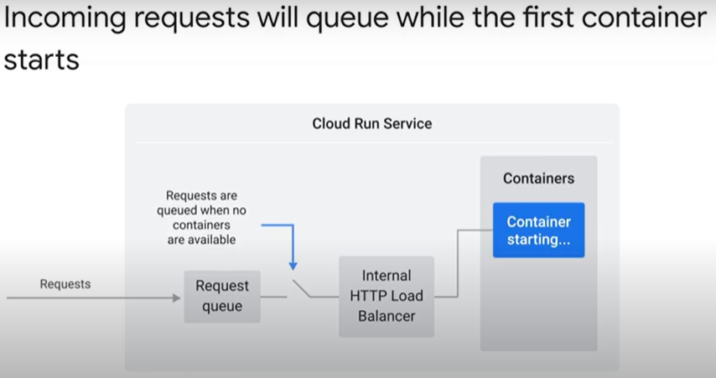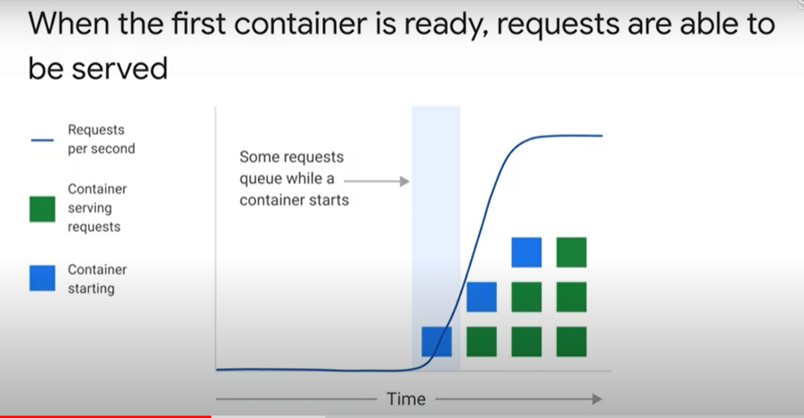
  + 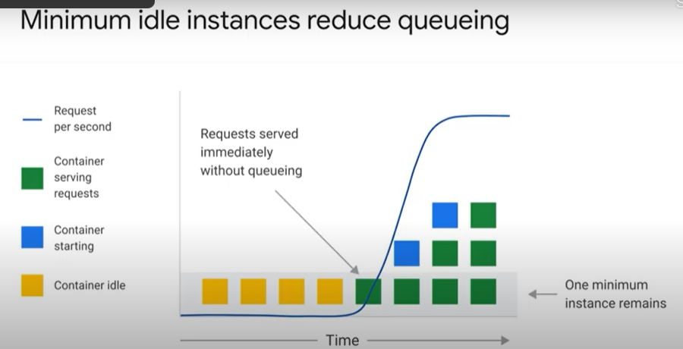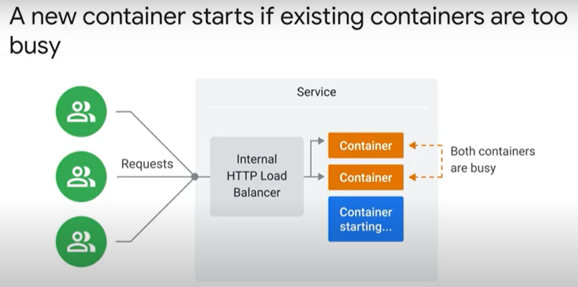
  + 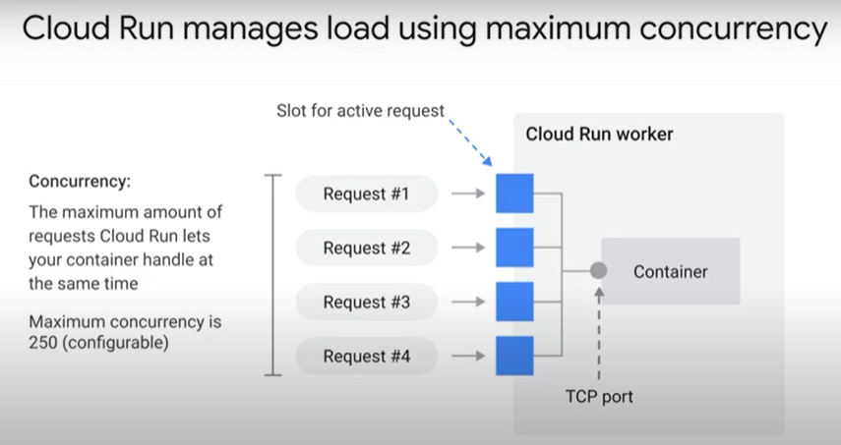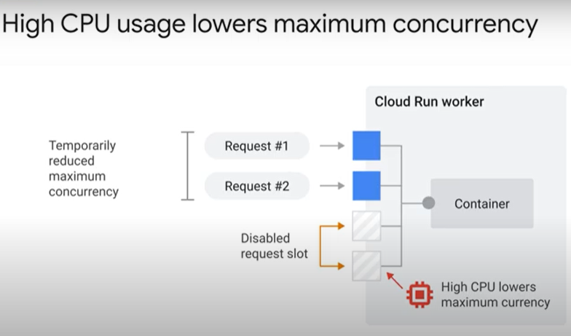
  + 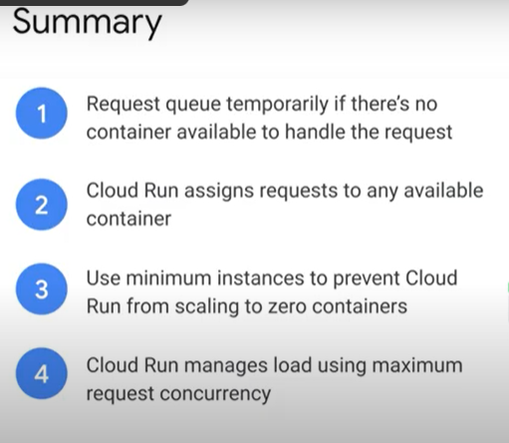
* Deployments 8 minutes - <https://youtu.be/gm7rXWwb2Ok>
  + 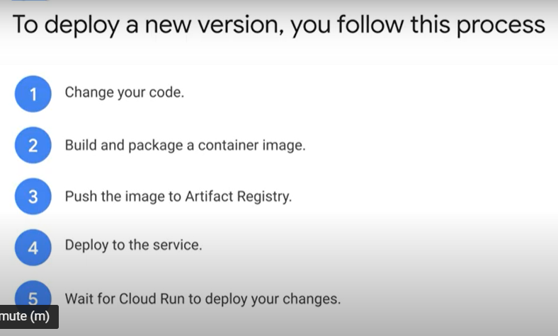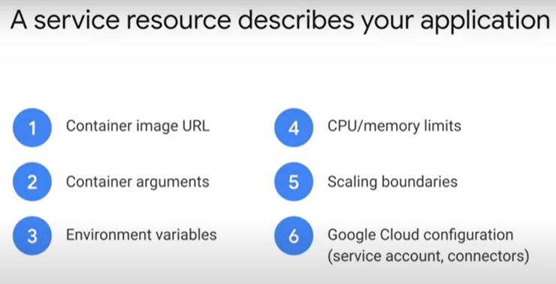
  + 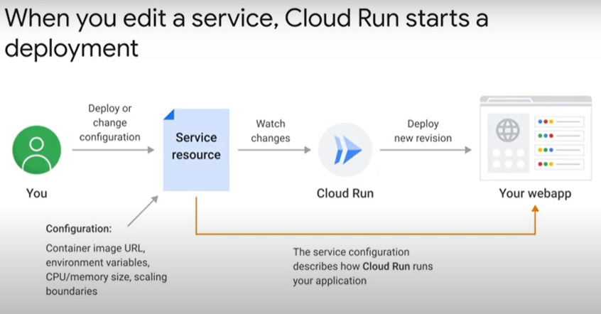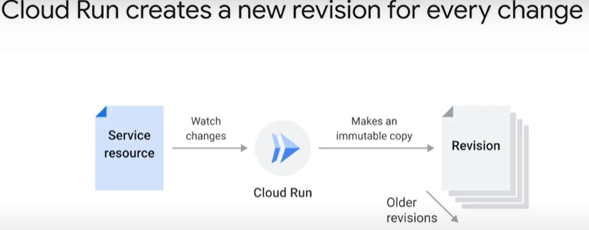
  + 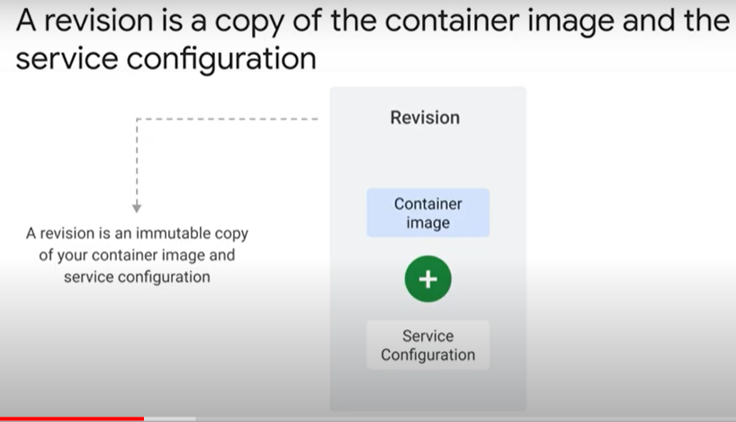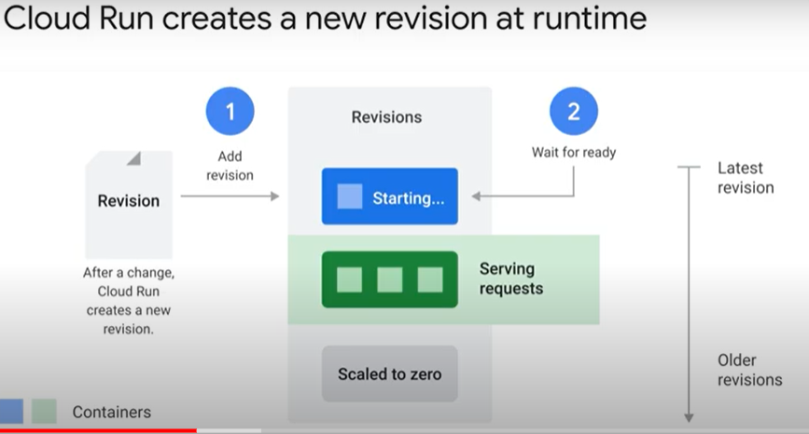
  + 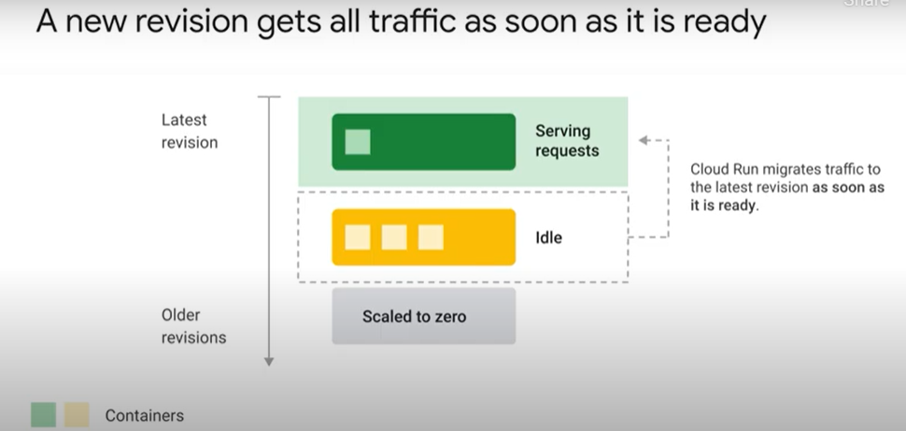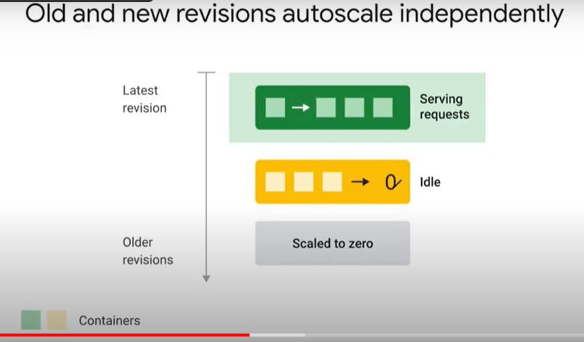
  + 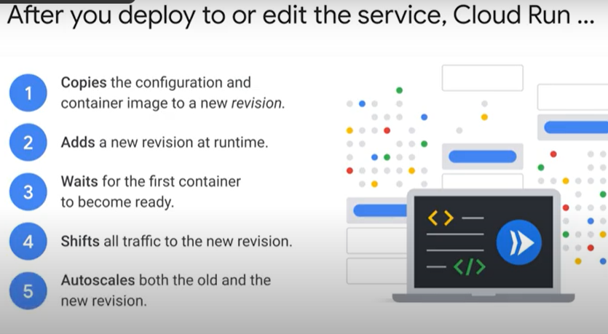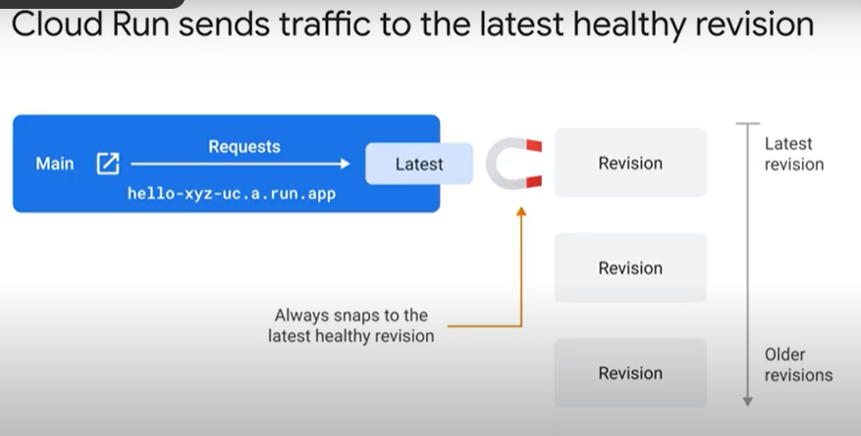
  + 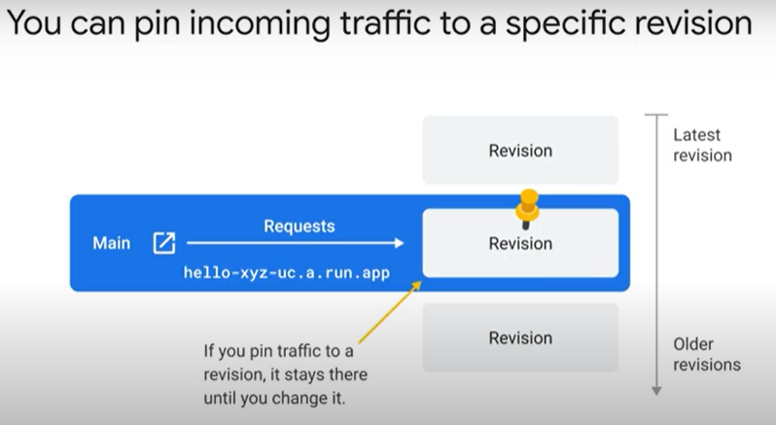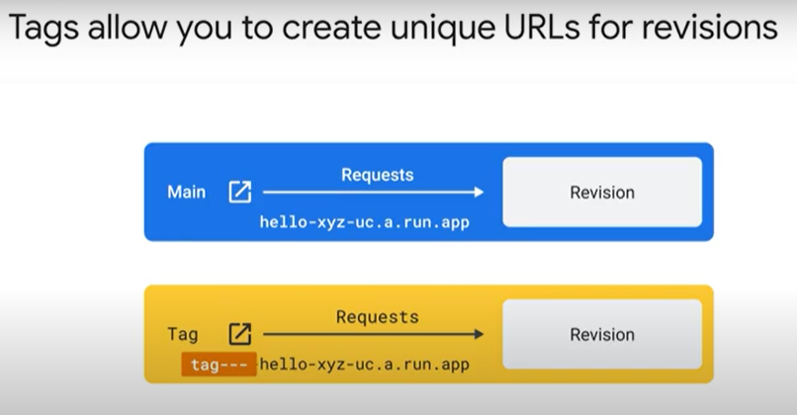
  + 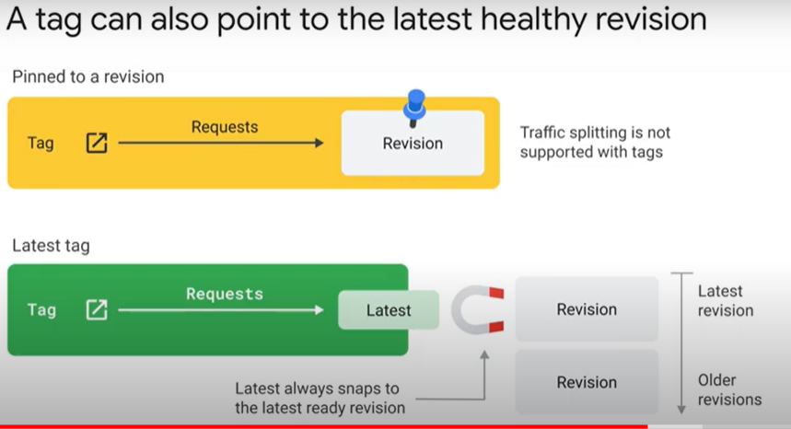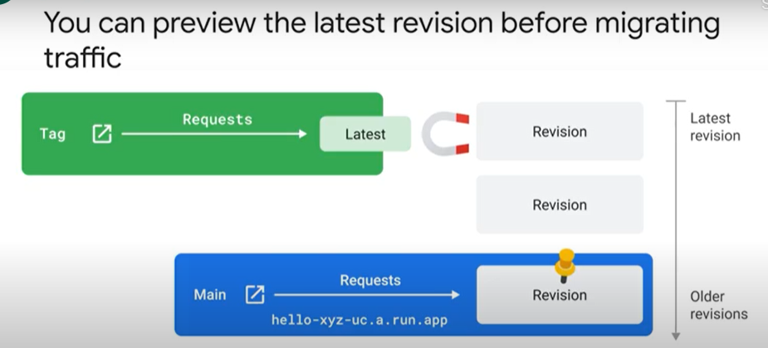
  + 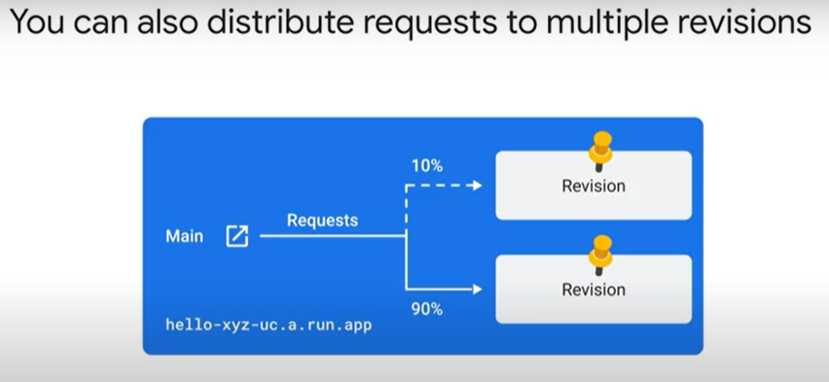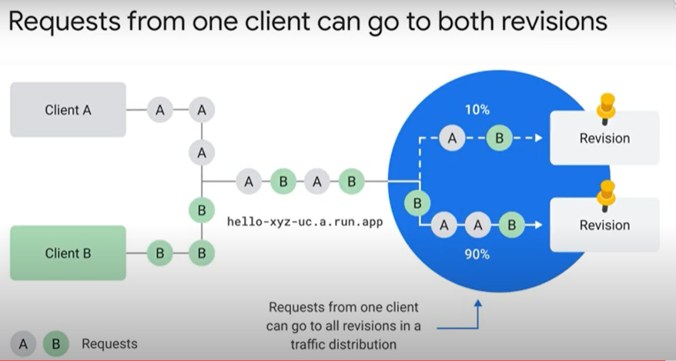
  + 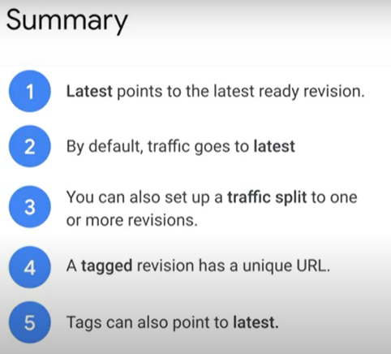

### Traffic Management with Cloud Run [APPRUN] 1 hour

* + Overview
    - Cloud Run allows you to specify which revisions should receive traffic and to specify traffic percentages that are received by a revision. This feature allows you to rollback to a previous revision, gradually roll out a revision, and split traffic between multiple revisions.
    - learn how to use Cloud Run features. The lab features three high level sections that resolve a technical problem:
      * Situational Overview
      * Requirements Gathering
      * Developing a minimal viable product
  + Prerequisites
    - These labs are based on intermediate knowledge of Google Cloud:
      * Cloud Build
      * Cloud Run
  + Situational Overview
    - In this lab, you will help the development team at Critter Junction investigate Cloud Run revisions. The team would like to explore how revision management can be incorporated into their existing development workflow.
  + Requirements Gathering
    - The operations team at Critter Junction would like to create a status page for their services without introducing additional complexity to their existing systems. Experimentation with Serverless products has led them to select Cloud Run due to the wealth of features supported.
    - Defining the service priorities
      * The operations team at Critter Junction are keen to define a solution that can be implemented quickly. After discussions with the engineering team, they discovered that serverless may be a good option. To move forward, a series of meetings are held with stakeholders to ascertain the key priorities. The results of which are shown below:

|  |  |
| --- | --- |
| **Ref** | **User Story** |
| 1 | As a product lead, I want to ensure the website remains responsive, so customers face minimal wait times. |
| 2 | As a developer lead, I want to increase the velocity of service deployments. |
| 3 | As an ops lead, I want to ensure system stability is observed, so the system performance is not degraded through the deployment of new revisions. |

* + - * The team leads follow up the meetings and agree the following high level tasks would indicate the project requirements have been met:

|  |  |
| --- | --- |
| **Ref** | **Definition of Done** |
| 1 | User base are not impacted by the rollout of new features |
| 2 | Revision management enabled for service deployments |
| 3 | New revision retains existing level of operational stability by deployment to a reduced user base |

* + - * In consideration of the requirements, the development team decide to look in to the following:
        + Traffic Migration
        + Revision Tags
    - Traffic Migration versus Revision Tags

|  |  |
| --- | --- |
| **Feature** | **Description** |
| *Revision Tags* | *"Appropriate for use cases where a task producer needs to defer or control the execution timing of a specific webhook or remote procedure call."* |
| Traffic Migration | "Cloud Run allows you to specify which revisions should receive traffic and to specify traffic percentages that are received by a revision.." |  |

* + - * The following high level architecture diagram summaries the minimal viable product they wish to investigate.
    - MVP Architecture
      * + 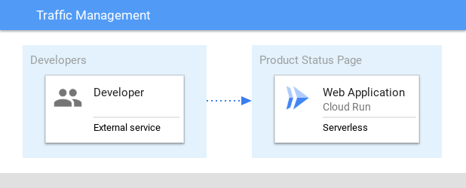
      * In the proposed solution, the product service is used to demonstrate how traffic migration and revision tagging can be used with Cloud Run.
  + Developing a minimal viable product (MVP)
    - Critter Junction has a backend product status service that they would like integrated with Cloud Run. To build an MVP the following activities are required:
      * Configure the environment
      * Test Revision Tags
      * Test Traffic Migration
      * Deploy a public service
  + Configure the environment
    - Cloud Run requires some environmental settings. In this section, enable the API and deploy the service.
    - Enable Cloud Run API
      * gcloud services enable run.googleapis.com
      * gcloud config set compute/region us-central1
      * LOCATION="us-central1"
    - Deploy a service
      * The development team needs to configure the product status service. To test the process, the development team decided to look at the deployment patterns for Cloud Run.
      * An example series of container images has been created by the development team. Use these images to configure and deploy within the project:
      * Deploy the payment service
        + gcloud run deploy product-service \
        + --image gcr.io/qwiklabs-resources/product-status:0.0.1 \
        + --tag test1 \
        + --region $LOCATION \
        + --allow-unauthenticated
      * Add the product status service to an environment variable
        + TEST1_PRODUCT_SERVICE_URL=$(gcloud run services describe product-service --platform managed --region us-central1 --format="value(status.address.url)")
      * Test the API is online
        + curl $TEST1_PRODUCT_SERVICE_URL/help -w "\n"
      * Example Output:
        + API Microservice example: v1
      * Test the product status is responding
        + curl $TEST1_PRODUCT_SERVICE_URL/v1/revision -w "\n"
      * Example Output:
        + {"api":"version 1"}
      * Note: Traffic Management
        + 100 percent of traffic is being served to the revision TEST1
        + Service is accessible and set to the default
      * The Cloud Run service has been successfully deployed and is responding to requests. In the next section explore how to utilise Traffic Migration to specify which revision receives traffic.
  + Revision Tags
    - Each new Cloud Run revision can be assigned a tag. Doing this allows access to a URL without serving traffic. An approach like this can be useful to handle the traffic profile across multiple revisions.

|  |  |
| --- | --- |
| **Use Case** | **Description** |
| Integration testing | Run containers revisions during the development phase |
| Tagged revision migration | Migrate traffic to a tagged revision |
| Tagged revision rollback | Rollback to prior version based on tagged revision |

* + - In this section deploy a new revision and learn how to control the traffic to direct to the correct destination.
    - Revised Architecture
      * 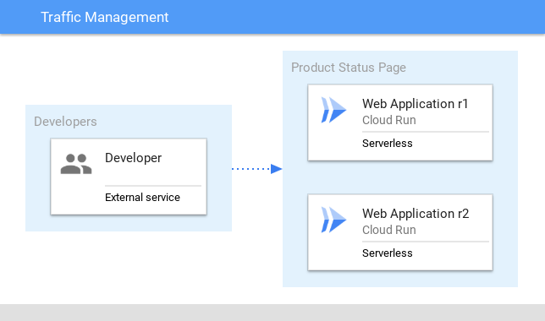
    - Integration Testing
      * Cloud Run provides the ability to deploy a new revision with redirecting traffic. A deployment of this kind is useful for integration testing of components.
      * Deploy a new tagged revision (test2) with redirection of traffic
        + gcloud run deploy product-service \
        + --image gcr.io/qwiklabs-resources/product-status:0.0.2 \
        + --no-traffic \
        + --tag test2 \
        + --region=$LOCATION \
        + --allow-unauthenticated
      * Observe the name of the Tagged Revision in the command output
      * Create an environment variable for the new URL
        + TEST2_PRODUCT_STATUS_URL=$(gcloud run services describe product-service --platform managed --region=us-central1 --format="value(status.traffic[2].url)")
      * Test the tag revision is able to receive traffic
        + curl $TEST2_PRODUCT_STATUS_URL/help -w "\n"
      * Example Output:
        + API Microservice example: v2
      * The new revision can be used to independently test the deployment. At this point the original revision is still serving 100% of the traffic.
    - Revision Migration
      * There are now two versions available. However only one revision is serving traffic. Alter the deployed revisions to share the traffic profile.
      * Migrate 50% of the traffic to the revision tag test2
        + gcloud run services update-traffic product-service \
        + --to-tags test2=50 \
        + --region=$LOCATION
      * Observe the name of the Tagged Revision in the command output
      * Confirm the original test endpoint is distributing traffic
        + for i in {1..10}; do curl $TEST1_PRODUCT_SERVICE_URL/help -w "\n"; done
      * Example Output:
        + API Microservice example: v1
        + . . .
        + API Microservice example: v2
      * At this point observe the traffic pattern is distributed between the original (TEST1) and new revision (TEST2).
    - Tagged revision rollback
      * In the event an issue is found, the traffic migration can be rolled back by resetting the percentage.
      * Migrate the distributed traffic back to the test1 service
        + gcloud run services update-traffic product-service \
        + --to-tags test2=0 \
        + --region=$LOCATION
      * Observe the name of the Tagged Revision in the command output
      * Test the endpoint is distributing traffic to TEST1 only
        + for i in {1..10}; do curl $TEST1_PRODUCT_SERVICE_URL/help -w "\n"; done
      * Example Output:
        + API Microservice example: v1
      * In this section a second Cloud Run revision was deployed and used to migrate traffic. The second revision was labelled with the tag test2 and used to migrate a percentage of the traffic determined at deployment.
  + Traffic Migration
    - Migration of traffic provides a simple mechanism on which to direct communication to a deployed service. Cloud Run provides the ability to have multiple revisions to be deployed without a cost penalty. Remember Cloud Run only charges where traffic is handled by the service.
    - The main uses cases for traffic migration are shown in the following table:

|  |  |
| --- | --- |
| **Use Case** | **Description** |
| Traffic migration | Enable traffic to be sent to the latest version of the deployed service |
| Traffic splitting | Perform a ratio traffic split between defined deployed services |
| Rollout migration | Deploy a service and gradually enable traffic at a predetermined time |

* + - Revised Architecture
      * + 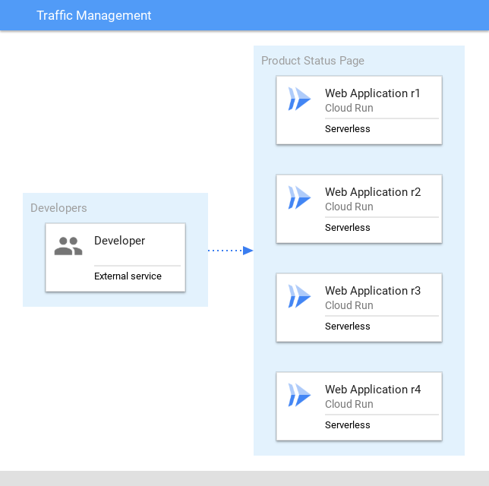
      * In this section multiple revisions will be deployed. Learn how to split traffic to a specific host.
    - Traffic Migration - Deploy a new version
      * When splitting traffic between two or more revisions, a comma separated list can be used. The list represents the revisions deployed.
      * Deploy a new tagged revision (test3, test4) with redirection of traffic
        + gcloud run deploy product-service \
        + --image gcr.io/qwiklabs-resources/product-status:0.0.3 \
        + --no-traffic \
        + --tag test3 \
        + --region=$LOCATION \
        + --allow-unauthenticated
        + gcloud run deploy product-service \
        + --image gcr.io/qwiklabs-resources/product-status:0.0.4 \
        + --no-traffic \
        + --tag test4 \
        + --region=$LOCATION \
        + --allow-unauthenticated
      * Output a list of the revisions deployed
        + gcloud run services describe product-service \
        + --region=$LOCATION \
        + --format='value(status.traffic.revisionName)'
      * Create an environment variable for the available revisionNames
        + LIST=$(gcloud run services describe product-service --platform=managed --region=$LOCATION --format='value[delimiter="=25,"](status.traffic.revisionName)')"=25"
      * Split traffic between the four services using the LIST environment variable
        + gcloud run services update-traffic product-service \
        + --to-revisions $LIST --region=$LOCATION
      * Observe the name of the Tagged Revision in the command output
      * Test the endpoint is distributing traffic
        + for i in {1..10}; do curl $TEST1_PRODUCT_SERVICE_URL/help -w "\n"; done
      * Example Output:
        + API Microservice example: v4
        + API Microservice example: v1
        + API Microservice example: v2
        + API Microservice example: v4
        + API Microservice example: v3
        + API Microservice example: v1
        + API Microservice example: v2
        + API Microservice example: v2
        + API Microservice example: v4
        + API Microservice example: v3
      * In this section a Cloud Run deployment was performed. Traffic was then diverted to the new deployment.
    - Traffic Splitting - Update traffic between revisions
      * Reset the service traffic profile to use the latest deployment
        + gcloud run services update-traffic product-service --to-latest --platform=managed --region=$LOCATION
      * Observe the name of the Tagged Revision in the command output
      * Create an environment variable for the new URL
        + LATEST_PRODUCT_STATUS_URL=$(gcloud run services describe product-service --platform managed --region=$LOCATION --format="value(status.address.url)")
      * Test the tag revision is able to receive traffic
        + curl $LATEST_PRODUCT_STATUS_URL/help -w "\n"
      * Example Output:
        + API Microservice example: v4
      * Critter Junction have now updated their solution to take advantage of Cloud Run traffic management.
* Quiz
  + Which of the following situations may result in your container stopping suddenly: (select all that apply)
    - The container has exceeded the configured memory limit (default 256Mb)
    - There is an error in your application code
  + By building your application to handle a SIGTERM signal, you can use ten seconds shutdown grace time to: (select all that apply)
    - Flush buffers with telemetry data
    - Close connections to your database
  + If Cloud Run starts a new container, when does it start to forward new web requests?
    - As soon as the container accepts TCP connections on the configured port
  + What is one of the benefits of using minimum instances?
    - It improves request latency when the service has not received requests for a while